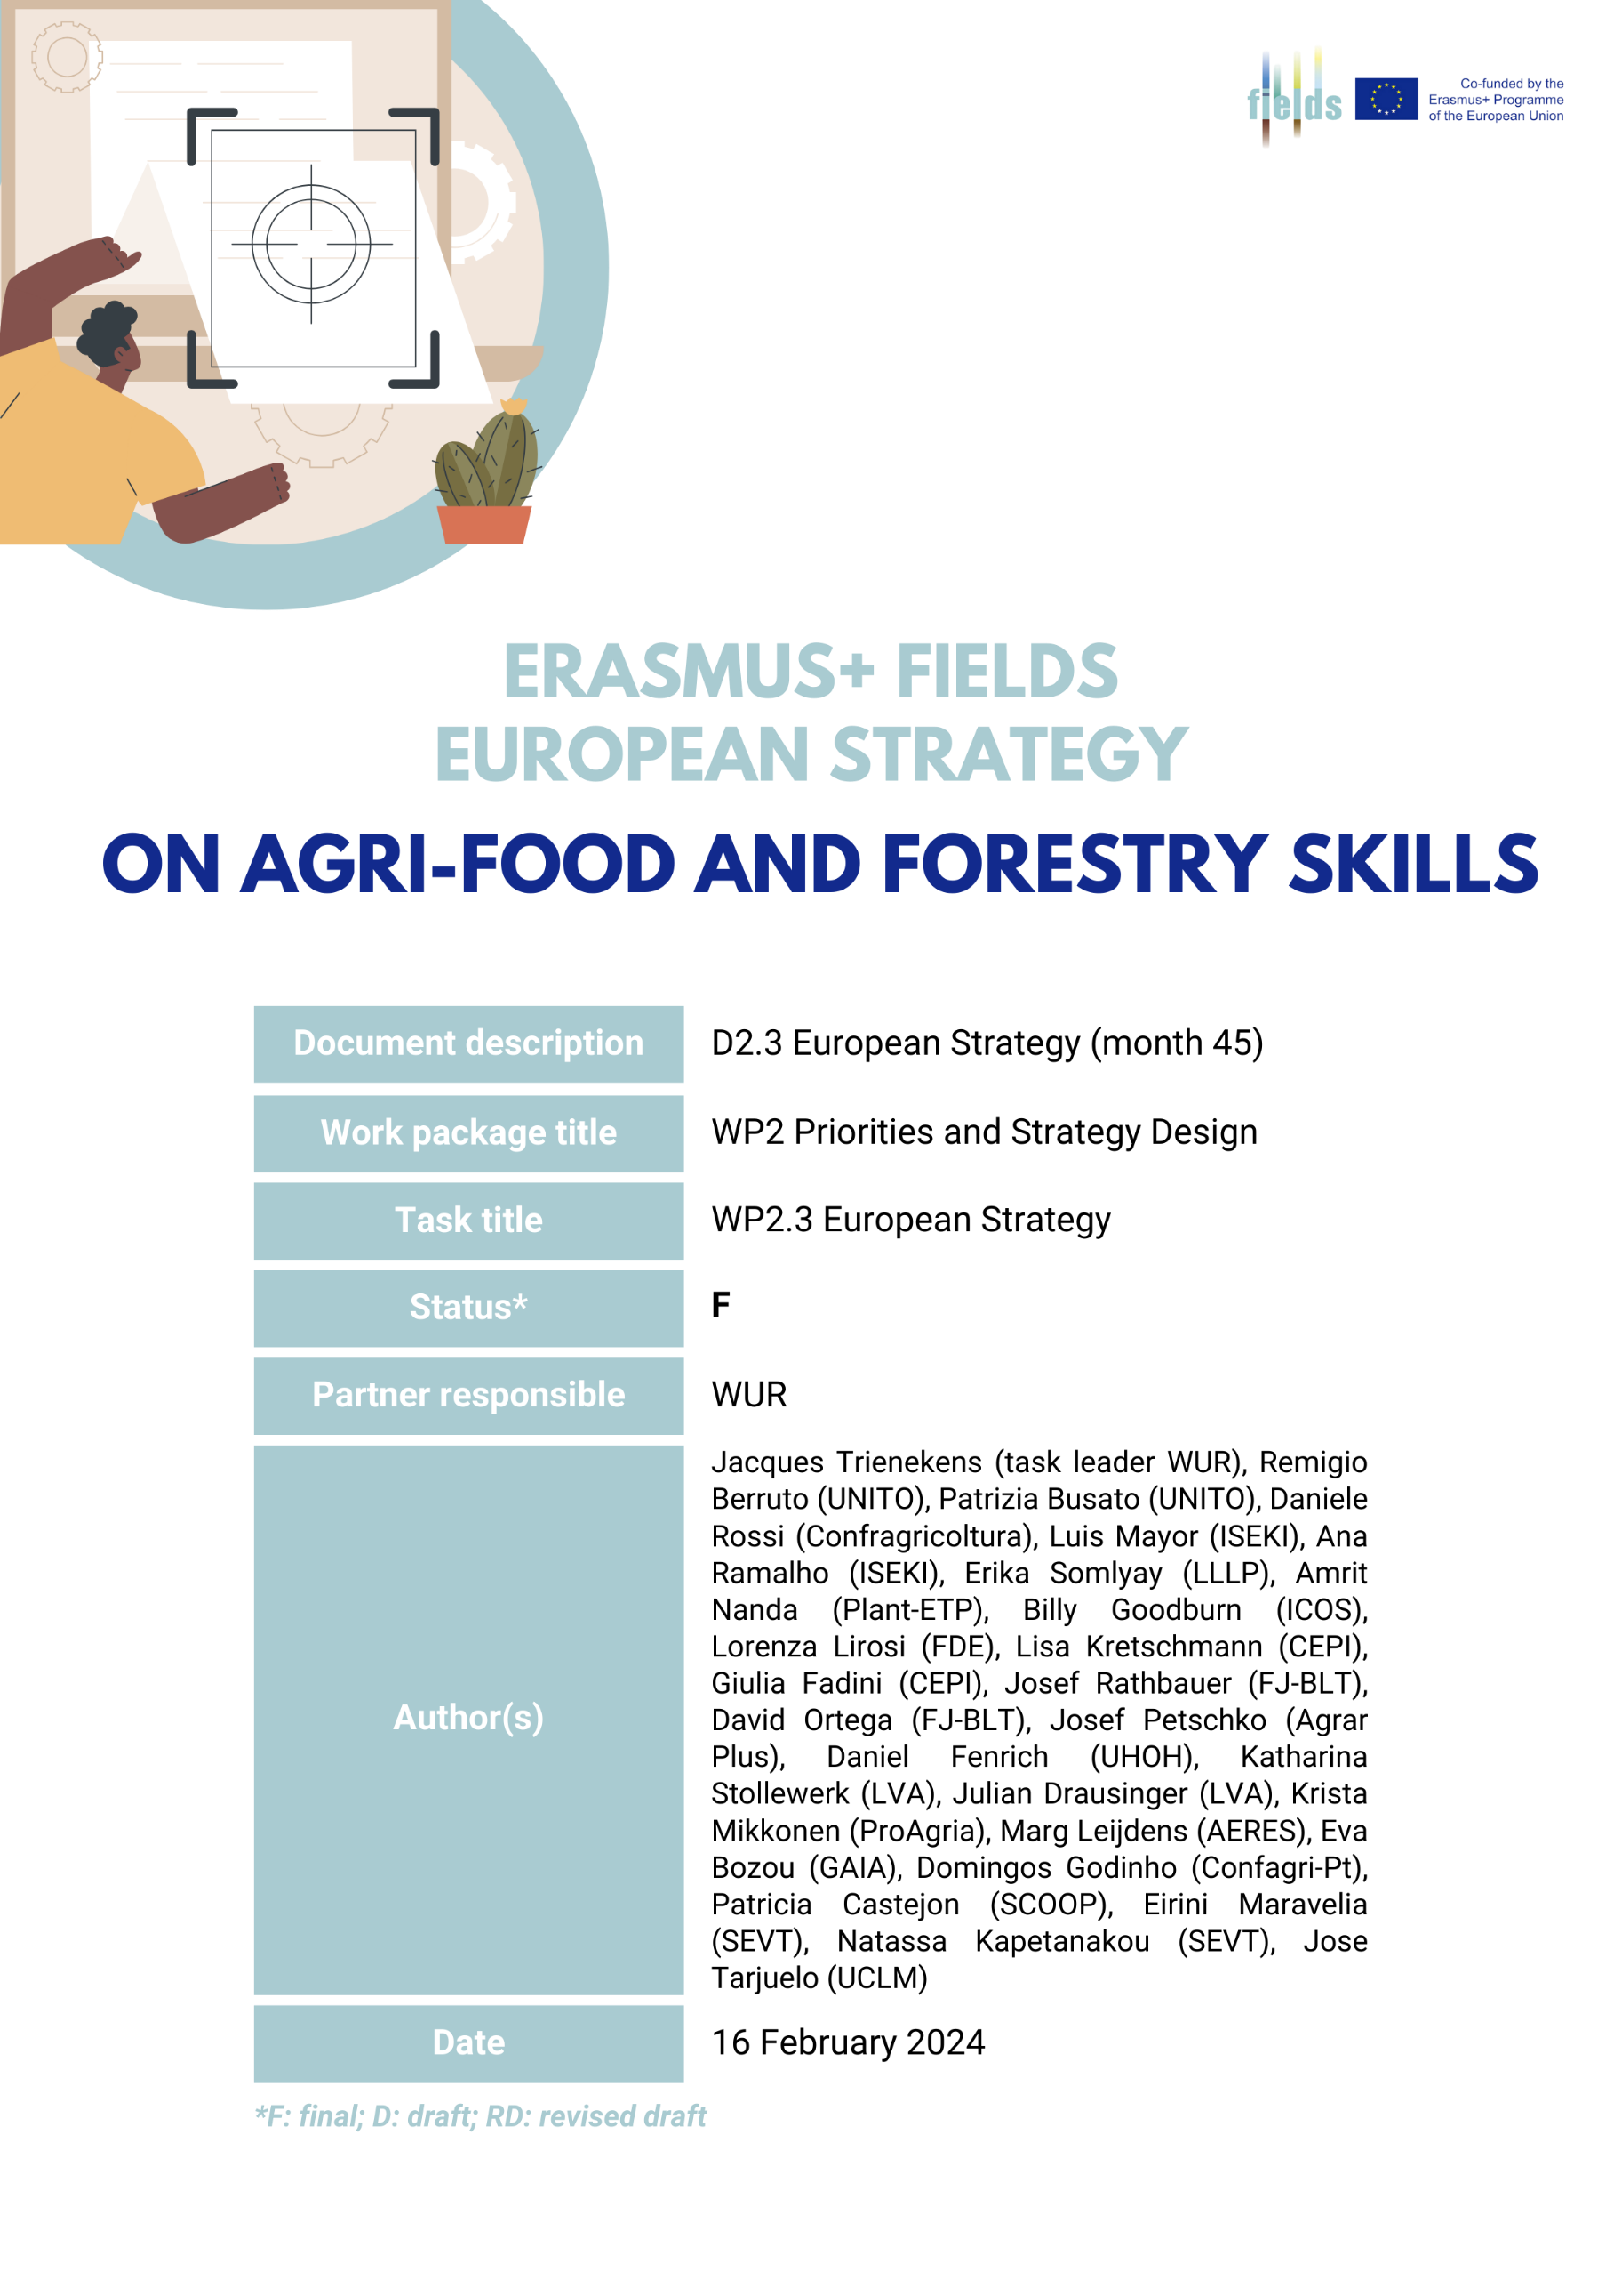
Contents
1. Introduction and method 4
1.1 Method 4
2. Social-economic trends and scenarios 6
2.1 D1.8 trend analysis and recent trends 6
2.2 Country differences in trends 9
2.3 EU policy trends 11
2.4 Three scenarios for the European agriculture, food industry and forestry 12
2.5 Impact of recent trends on scenarios 14
3. Specification of skill needs 15
3.1 Impact of recent trends on skill needs 17
4. Labour market requirements and developments in VET systems 18
4.1 Labour market 18
4.2 Supply of education and training 19
4.3 Country differences in labour market and education and training supply 20
5. Regulatory framework and funding challenges 22
5.1 EU and country regulatory framework 22
5.2 Funding 23
6. Key requirements of training programs 27
6.1 Key elements and prerequisites of VET programs 27
6.2 Key performance indicators 30
6.3 Training and education methodologies 31
7. Organisational directions: towards a balanced governance structure of the European skills ecosystem 32
7.1 Introduction 32
7.2 VET Organization and change in various countries 33
7.3 Governance functions 35
8. Conclusion and key strategic directions 39
8.1 Introduction 39
8.2 Skill needs and training offer 40
8.3 Regulatory system and funding 41
8.4 Key elements and prerequisites for future VET programs 42
8.5 Governance functions in the future VET eco-system 43
8.6 Use of this report and further steps 44
Annex 1 Task 2.3 Phase 1 methodology and questionnaire 45
Questionnaire FIELDS D2.3 survey part 1 45
Annex 2 Task 2.3 Phase 2 methodology and questionnaire 47
Questionnaire FIELDS D2.3 Survey part 2 (country level) 47
Annex 3 Partner organisations in Erasmus+ FIELDS 50
Annex 4 Typical agri-food and forestry challenges across 6 EU countries 51
Annex 5 Job profile - example Technician for sustainable agriculture 52
Annex 6 Applicable EU Regulations (Source: FIELDS project database) 53
Annex 7 Respondent views on monitoring systems (WP2.3 survey phase 1) 56
Annex 8 VET system governance descriptions of 5 EU countries 57
References 60

Introduction and method
One of the tasks in the FIELDS project is the development of a European Strategy for skills enhancement in the agriculture, food industry and forestry sectors (task 2.3). On the one hand the EU strategy includes key aspects and general guidelines that will be further completed by roadmaps at a national level (task 2.4) in order to support knowledge transfer and skill creation for these sectors. On the other hand, this task aims to set up a bridge to the Erasmus + project I-Restart (started in September 2022), and to jointly link up with the Agri-food Pact for Skills (established in 2022), coordinated by the European association for the food and drink industry, FoodDrinkEurope, and the European association of cooperatives and farmers, Copa-Cogeca. In the outline of the Pact as proposed on the 18th of October 2021 the Agri-Food Pact for Skills partnership aims: ’’… to set a joint strategy to design and implement a sectorial upskilling and reskilling framework, maximising competitiveness of all the actors involved, job retention and job attractiveness for the agri-food system within the Pact for Skills’’ (FoodDrinkEurope, CopaCogeca, 2021; Pact for skills, 2021; Lazaro-Mojica & Fernandez, 2021). This report aims to support the design of a strategy for the European skills ecosystem, and provides the deliverable of FIELDS task 2.3: D.2.3 European Strategy.

Method
The execution of the task has been divided in two phases, consisting of expert surveys and supplemented by relevant outputs of other tasks in the FIELDS project and complementary information from two FIELDS-external foresight exercises:
1. The objective of the first phase, that started in autumn 2021, was to formulate key principles for the development of a European agri-food-forestry skills strategy, by collecting and analysing ideas and opinions of the wide range of experts collaborating in the FIELDS project. Therefore, a questionnaire survey has been performed, taking skill needs, as defined in FIELDS WP1, as a starting point. 25 experts from the FIELDS project participated in the survey (for a further description of the methodology and the questionnaire, see annex 1).
2. The second phase, that started in spring 2023, focused on organization and governance of the European skills ecosystem and also aimed at capturing ongoing changes in skill needs and training supply since 2021. Also in this phase, a questionnaire was distributed among experts in the FIELDS project, with 23 expert responses (for a further description of the methodology and the questionnaire, see annex 2).
Furthermore, the first author participated in two foresight exercises, including a series of EU-level expert sessions: a foresight study on the implications of the European Green Deal implementation on employment and skills from the agri-food sector perspective, performed by CEDEFOP (Cedefop, 2023), and an EC study on Promoting Education, training and skills across the bioeconomy (EU, 2022). Results of these studies are integrated in the present analysis.
Moreover, research reports and policy documents related to the European skills ecosystem were consulted. As the final step in the analysis the draft report has been sent to the project partners for a round of in-depth comments and a workshop has been held with a representation of key project partners to finalize and conclude the report.
The report builds on several other tasks executed in the FIELDS project:
- Results of a European agri-food and forestry trends analysis and design of three scenarios for these sectors (D1.8 Scenario analysis)
- Results of focus groups discussions in 11 EU countries and on EU level on agri-food and forestry skill and training needs (D1.5 Focus group analysis), as well as a European survey on skill and training needs (D1.7 Survey analysis)
- Inventory of stakeholders (D1.3 VET list and classification), Occupational profiles (D2.1 Detailed baseline of occupational profiles)
- National roadmaps developed in 7 countries (D2.4: national roadmaps)
- Methodological considerations (D3.1 Training methodologies)
- A study into apprenticeship schemes in the EU ( D3.3 Apprenticeship scheme report)
- Information on national and EU level regulations and funding opportunities (D5.1 Regulatory framework list; D5.2 Funding opportunity)
Section 2 presents results of the trend and scenario analysis, section 3 presents key skill needs as outcome of the FIELDS WP1 tasks 1.3 and 1.4, section 4 goes into labour market requirements and developments in the VET system. Section 5 discusses regulatory framework and funding challenges, while section 6 defines key elements and prerequisites of VET programmes. Section 7 presents a governance strategy for the European skills ecosystem. Section 8 concludes and proposes key elements of an overall European skill strategy.

Social-economic trends and scenarios

D1.8 trend analysis and recent trends
In work package 1 of the FIELDS project a trend analysis was performed in 2021 to analyse the future needs in the FIELDS of sustainability, bio-economy, digitalisation and management & entrepreneurship of the European agriculture, food industry and forestry sectors (see FIELDS deliverable D1.8 Trend and Scenario analysis).
Trend studies usually distinguish between megatrends and trends. Megatrends are defined according to OECD (2016), as ‘’large-scale social, economic, political, environmental, or technological changes that are slow to form, but which, once they have taken root, exercise a profound and lasting influence on many if not most human activities, processes and perceptions.’’ Trends, contrary to megatrends, focus at smaller, regional, or sectoral scale. The Horizon 2020 project Fit4Food2030 (Fit4Food2030.eu D2.1, page 4): identifies 11 megatrends (Table 1) linked to Global socio-economic-technological developments.
Megatrends identified by the Fit4Food2030 project
Climate Change  Malnutrition  Rise of Non-Communicable Diseases  Urbanisation  Demographic Change  Migration | Scarcity of Natural Resources  Rise in Energy Consumption  Industry 4.0 – Digitization  Big Data Analysis  Economic Globalisation
Table 1 Megatrends identified by the Horizon2020 project Fit4Food2030

These megatrends have been specified for their impact on agriculture and the food industry in the EU. (for an overview of all trends identified in the project Fit4Food2030, see Wepner et al., 2019). In the FIELDS project, we specifically focused on trends in the four dimensions of the FIELDS project: sustainability, bioeconomy, digitalisation and management/entrepreneurship and soft skills. The study was performed by a group of experts from the FIELDS project through an extensive literature analysis, including sector and policy documents, for the agriculture, forestry and food industry. Table 2 gives an overview of identified trends in agriculture, the food industry and forestry grouped into the categories Sustainable production, Bio-economy, Digitalisation, and Business models. (see for the detailed literature analysis: FIELDS D.1.8, 2021)

Identified trends in Agriculture, Food industry and Forestry
Sustainability | Agriculture: increase of Integrated pest management, increase of Integrated nutrient management, more attention to Agricultural pollution and GHG emissions, increase of Organic farming and Extensive production systems, more attention to Animal welfare, better management of Scarce natural resources (land, nutrients), pressure on Water resources, attention to Biodiversity and conservation of Eco-systems, more attention to Food waste and loss  Forestry: large scale Forest disturbances (droughts, heat waves, etc.), negative impact of Climate change on Tree species and Biomass characteristics, Biodiversity challenges, Illegal logging, Fragmentation of ownership, Health and safety challenges  Food Industry: new Technologies to deal with food waste and loss, more Circular production, more attention to Energy efficiency, Environmental footprint, Smart logistics systems, Clean and ‘’green’’ labels, and Healthier consumer diets
Bioeconomy | Agriculture: increase in Biomass production and transformation, more use of Renewable energy, growth of Bio-based products, more Resource-efficient technologies and Reduction of losses, more attention to Circularity of production, Biodiversity  Forestry: increase in Biomass production and transformation, more use of Renewable energy, growth of Bio-based products and Eco-system services, Increasing demands for wood, more attention for Urban green spaces/forests  Food Industry: better use of Food waste, developments towards Circular production, focus on Energy efficiency and Biomass transformation, Bio-based products, Bio-based packaging, New proteins
Digitalisation | Agriculture: growth of On-farm applications (combined technologies), Integrated FMIS, Big Data analysis and Agriculture 4.0, better Traceability of produce, increase of use of Supply Chain information systems, New customer relationships  Forestry: growth of In-forest applications (combined technologies), Mechanised harvesting, better organised Timber transport and traceability, growth in use of Forestry management information systems  Food Industry: more effective Food processing control, Food supply-chain monitoring, innovative Factory design and Industry 4.0, Robotics, use of Digital twins and augmented reality, 3D Printing/additive manufacturing, New technologies in processing and packaging
Business Models | Agriculture: Changes in farm structure, developments towards Multi-functional farms, Urban farming and Indoor cultivation systems, more attention to Health and food consciousness of consumers, growing importance of Traceability, emerging Short food supply chains and Local/regional products  Forestry: growing Economic importance of forests, increasing attention to Urban green spaces, Fragmentation of ownership, lasting Lack of forest entrepreneurship, improvements in Weak infrastructure and use of New technology  Food industry: increasing Complexity of consumer demands and New diets, Interaction with consumers becomes more important, New logistics and e-commerce, more attention to Short food supply chains, Novel foods, New packaging
Table 2 Identified trends in agriculture, forestry and the food industry in Europe (FIELDS deliverable 1.8, Trienekens et al., 2021)
In recent years several key developments in the business environment have heavily impacted on the agri-food and forestry system in Europe, as there are the Covid-19 pandemic, the Ukraine war and the energy crisis.
Important effects of the Ukraine war and energy crisis are (Zachmann et al, 2022; Jagtap et al, 2022; Ben Hassen & El Bilali, 2022):
- Food insecurity and humanitarian crises in poorer countries throughout the world,
- Rising prices of energy and food products in the EU, leading to high, ongoing, inflation figures (e.g. up to 40% in Hungary and 30% in Lithuania in September 2022), in particular impacting on lower income groups in the EU (Ihle, 2022).
- Sharp rising prices of farmer inputs, including natural gas, electricity, fertilizers, transport fuel, packaging, and external labour (Copa Cogeca, 2022). A specific effect is the further reduction of nitrogen surplus in fertilizer content, and reduced use of fertilizers because of the strong dependence on the delivery of nitrogen fertilizers by the Russian Federation (Haller, 2022).
However, the overall effects on EU agriculture were limited. Imports from Ukraine did not collapse, and also total EU imports were barely affected. The crisis even stimulated the wheat export from EU countries, although the EU was a net trade balance looser due to massive energy imports. Although energy costs showed sharp rises in prices, the impacts were limited as on average energy is only a small part of the total costs of agriculture (1.5-2.9%) and loss of value added, particularly in the processing chain, added up to 0.8-1%. (Ihle, 2022).
Despite the limited direct impact of these developments, in the last years in the agri-food and forestry system several indirect effects come forward:
- A growing interest of agri-food and forestry companies in short food chains and regional products, caused by the ongoing energy insecurity and logistics challenges caused by the political crises and the Covid-19 pandemic.
- A further increase in the use of new technologies by companies because of labour shortages and to better be able to deal with the uncertainties in the international food chain.
- More attention to the formation of alternative energy sources, alternative business functions and market relationships (supply and use of renewable energy).
To these ‘’new’’ trends (EIT, 2023) adds some trends that are coming up strong in 2023: the rise of alternative seafood companies (and a landmark initiative such as the EU’s algae approach), greater focus on diversity and the adaption of regional and local diets, the further investments in personalisation of food, and, in line with the above, the greater need for transparency in the food chain since Covid-19 and the need to automate and connect processes to achieve this and in order to
increase resilience in the food chain. Further, according to (EIT, 2023) consumer demands for more sustainability aspects become louder.

Country differences in trends
One finding of the trend analysis were the huge inter-country differences in the dimensions of our study. The differences between countries are dependent on key country characteristics such as digital infrastructure, level of sustainable production, farm/company structure, industry developments, level of education, etc. We will discuss these differences by giving one example/indicator for every of the dimensions of the trend study and present some key findings of the country analyses (see also FIELDS D1.8).

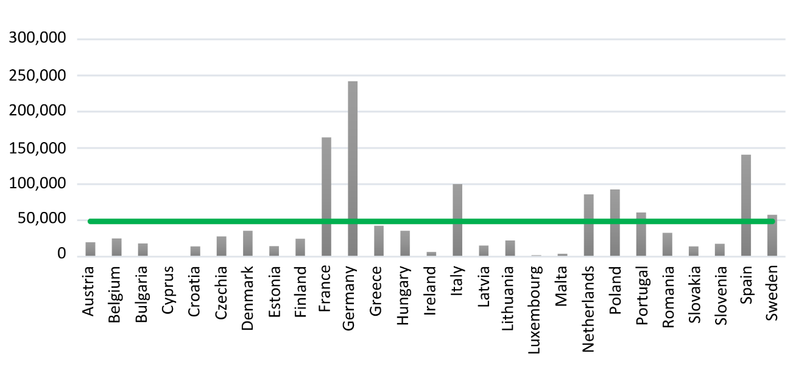
One of the key objectives of the European Green Deal is the achievement of 25% of the agricultural area in every country dedicated to organic production by the year 2030. Currently, 9.9% of agricultural land in the EU is dedicated to organic farming. Austria in this respect is the leading country with more than 25% organic production, followed by countries like Sweden and Estonia with around 20%. However, at the other end of the spectrum we see Eastern European countries like Poland, Romania and Western European countries like the Netherlands and Ireland that score less than 5% (Eurostat, 2023).
Figure 1 Organic area across EU countries, 2021 (Eurostat, 2023)

Figure 2 Green jobs in the EU renewable sector in 2020 – number of jobs per country (Kozar et al, 2022)

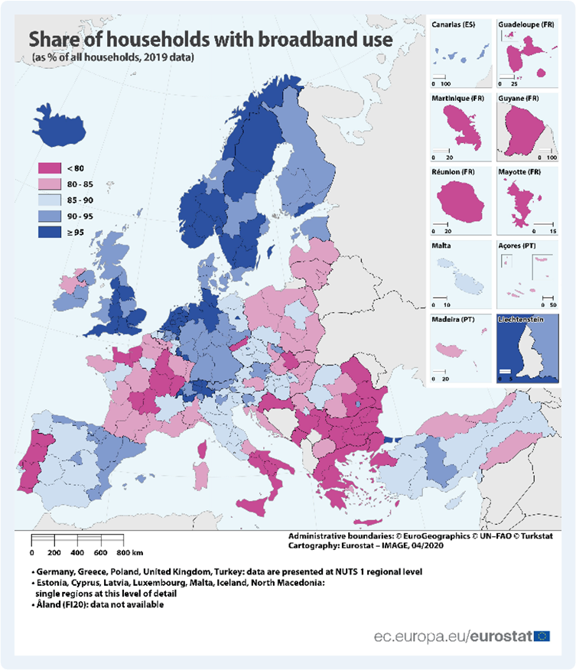
An important element of the green transition is the fast development of the renewable energy sector. Based on data from 27 EU countries over the period 2013–2020 (Eurostat and EurObserver) Kozar et al. observe a quick development towards the production and use of renewable energy. Figure 2 shows Germany, France and Spain having the largest industries (in terms of jobs), followed by Italy, Poland and The Netherlands. However, in many countries the developments are still moderate.
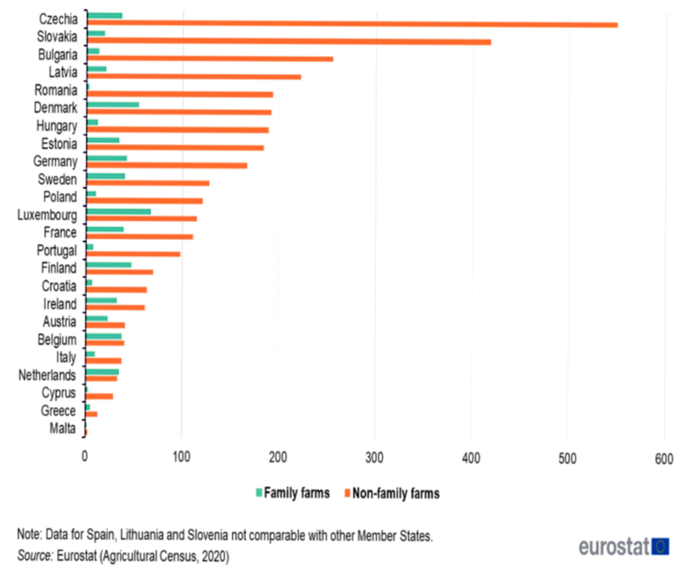
In the digitalisation dimension, the status and trend in the use of digital technologies in agri-food and forestry were investigated on EU and on country level. As an example for the different levels of development, we can point at the level of broadband coverage in the EU. Although countries invest highly in digitalisation, the current broadband coverage can be a constraint for digitalisation in several regions in Europe. This holds, in particular, for France, Spain, parts of Eastern Europe, parts of Finland, Sweden and Germany. The Dutch agricultural sector (e.g. dairy, horticulture) already has a strong history in digital technologies, related to its intensive farming systems; also Austria, Italy and Finland are innovative in this area, although the structure of the agricultural sector in, for example, Austria with its many small farms, may constraint the application of digital technologies (Eurostat, 2020; FIELDS D1.8)
Figure 3 Share of households with broadband use
(Eurostat, 2020)
Looking at the structure of agriculture, we can give the example of the large differences in farm size. Family farms in Western European countries are larger as compared to Southern European countries, while the average size varies for Eastern European countries. For the non-family farms, farm sizes are largest in several Eastern European countries. According to our country studies, the number of farms in the selected countries is decreasing fast, except for Ireland, where the number of farms is relatively stable.
Figure 4 Differences in average farm size (Eurostat, 2020a)

At the same time, the size of the remaining, most family farms increases. Farmers become entrepreneurs and multifunctional farming is growing fast, in particular in countries such as The Netherlands, Austria, France and Italy. Moreover, local-to-local chains are emerging in several countries like Austria, France, Italy and The Netherlands. (FIELDS D1.8; Eurostat, 2020)
A last point of differences lies in the agricultural knowledge and information system (AKIS) of European countries. The structure of the AKIS is quite different. Ireland and Austria have integrated and strong AKIS, while other countries like The Netherlands, Finland and France also have strong, but more fragmented AKIS (EU SKAR AKIS, 2019). The AKIS of most of the selected countries is considered strong, except for Italy and Spain.
These examples give a clear picture of the inter-country differences in the EU on dimensions of our study.
In FIELDS deliverable 1.8 the country studies that were performed as part of the WP1.5 trend analysis, also showed some remarkable difference in typical issues or challenges. Annex 4 describes examples of these differences for 6 EU countries.

EU policy trends
The trends described in the previous section are consistent with main EU policies in the FIELDS of sustainable and circular production. The European Green Deal, announced by the European Commission in December 2019, followed up on the UN Sustainable Development Goals (SDGs) and COP21 (the UN climate change conference of 2015). It commits the EU to become climate-neutral by 2050 whilst promising to help companies to become world leaders in clean products and green technologies. It aims to boost the efficient use of resources by moving to a clean, circular economy while restoring biodiversity and cutting pollution. The Green Deal encompasses a New Circular Economy Action Plan, a Sustainable Europe Investment Plan, a Biodiversity Strategy for 2030 and a new Farm to Fork strategy on sustainable food throughout the value chain (EU-Green Deal, 2021; EU, 2021a). For the FIELDS project, sustainable food production, biodiversity, and circular economy are key issues.
A circular economy is instrumental in delivering on the European Commission’s ambitions to decouple resource use from economic growth. The Green Deal aims to halt, and as much as possible reverse, the pressures we place on our planet’s resources, ecosystems, climate, and biodiversity. The Farm to Fork Strategy aims to enable the transition to a sustainable EU food system that safeguards food security and ensures access to healthy diets sourced from a healthy planet. The strategy sets concrete targets to transform the EU's food system, including a reduction by 50 % of the use of pesticides, a reduction by at least 20 % of the use of fertilizers, a reduction by 50 % in sales of antimicrobials used for farmed animals and aquaculture, and reaching 25 % of agricultural land under organic farming. It also proposes ambitious measures to ensure that the healthy option is the easiest for EU citizens, including improved labelling to better meet consumers' information needs on healthy, sustainable foods (EU-FarmToFork, 2021).
Biodiversity underpins vital environmental, social and economic functions. It is therefore not only placed at the heart of EU environmental policy, but the Commission wants biodiversity criteria to be fully factored into public, corporate and individual decisions at all levels, from farming and fisheries to trade, industry, energy, climate, and economic policy (Oneplanet, 2021).
Coherent with the Green Deal, the new (post 2020) Common Agricultural Policy (CAP) aims to foster a sustainable and competitive agricultural sector that can contribute significantly to the European Green Deal, especially with regard to the Farm to Fork, circularity, and biodiversity strategies. Action points of this policy instrument are as follows: - better integration of climate issues as well as environmental issues such as biodiversity protection, natural resource conservation, and soil health and fertility, - access to healthy food for all EU citizens, - promotion of sustainable agriculture (Farm to Fork initiative): reduction of chemical fertilisers, pesticides, and antibiotics, nutrient losses, increase of the organic farming area, - support of digitalisation of agriculture to improve sustainability and competitiveness (EU-CAP, 2020). From 2023 on Member States will be required to allocate at least 25% of their income support budget to ‘’eco-schemes’’ (EC, 2021) and at least 35% of CAP rural development funds will be allocated to agri-environmental commitments. Other key regulations to achieve the EU’s agri-environmental, biodiversity, and climate objectives include the Nitrates Directive (91/676/EEC), to reduce and prevent nitrate pollution of groundwater and surface water, the Sustainable Use of Pesticides Directive (2009/128/EC), to stimulate integrated pest management and find alternatives for chemical pesticides, the Habitats Directive (92/43/EEC), aims to ensure protection of habitats and species, the Water Framework Directive (2000/60/EC) and the EU Climate Law (EU 2021/1119). (Hasler et al., 2022)

Three scenarios for the European agriculture, food industry and forestry
For the scenario analysis, we built largely on a number of scenario development exercises by EU researchers in the past decade. Important studies include (1) the scenarios used in the framework of IPCC AR5, called Shared Socioeconomic Pathways (SSP) (O’Neil et al., 2014, 2017), (2) recent Horizon2020 projects building on these scenarios, like the SureFarm project, the TransMango project (Vervoort et al., 2016), EC Food Safety and Nutrition scenarios (Mylona et al., 2016), Agrimonde-Terra (Land use and Food security) scenarios (Mora, 2016), and (3) a recent academic study integrating results of various scenario studies based on the SSPs (Mitter et al., 2020). Further, we include an AKIS-SCAR scenario analysis (Poppe et al., 2016), as this study includes possible development pathways of the European knowledge and information system. This is relevant for our scenario analysis, indeed the FIELDS project should give input to this system. The scenario study was performed on EU level and on country level, for the same countries as the trend analysis.
Mitter et al. (2020) take many of the insights of the other scenario studies into account. As in other scenario studies, we include a scenario ‘on established pathways’, this is a scenario assuming developments according to historical patterns, without big changes to be expected in policies and economic, social and technology development. The two other scenarios include two pathways with alternative and distinct developments covering the dimensions of the trend study: sustainability, bio-economy, digitalisation and business models. For this, we initially follow Mitter et al. (2020) scenarios Sustainable Pathways and High-Tech Pathways. Sustainability covers the sustainability dimension in our project and, partly, the bioeconomy dimension (e.g. circular production). High Tech covers the digitalisation dimension and, partly, the bioeconomy dimension (e.g. renewable energy and bio-based products). The three scenarios provide a solid basis and starting point for the specification of sustainability, bioeconomy, digitalisation and business model trends in agriculture, the food industry and forestry sector (for an extensive description of the scenarios, see FIELDS D1.8 Trend and Scenario study, chapter 2).
The three scenarios are worked out for the FIELDS project by adding storyline elements from the areas Sustainability, Bio-economy, Digitalisation and Business models. These are derived from the European trend analysis (FIELDS D1.8, chapter 2). The FIELDS scenario storylines/narratives cover agriculture, food industry and forestry sectors, as well as the structure of the European AKIS. For a detailed description of the scenarios, we refer to chapter 3 of FIELDS D1.8 Trend and Scenario Analysis.
Table 3 presents main characteristics in key words of the scenarios in the FIELDS dimensions sustainability, bio-economy, digitalisation and business models (FIELDS D1.8 Scenario Analysis).
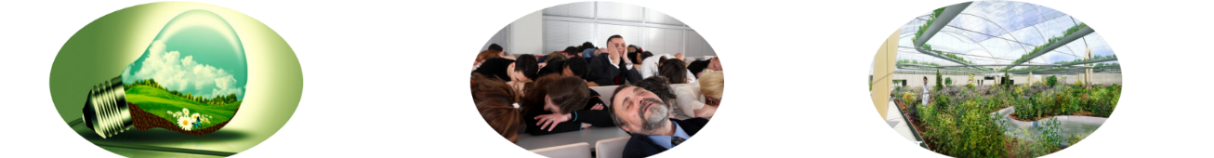

Scenario Sustainable Paths | Scenario Established Paths | Scenario High Tech Paths
Sustainable production
- Sustainable plant-based consumption  - Diversified cropping systems  - Growing agro-forestry  - New proteins | - Cost, taste and convenience important for consumers  - Intensive agricultural production remains  - Non sustainable management in scattered forests  - Processing technology focuses on efficiency | - Healthy personalised diets  - Technology intensive large-scale production  - Technology intensive commercial forestry  - Innovative products and processes in food industries
Bioeconomy
- Decarbonised energy markets  - Food waste and losses minimised  - Sustainable multi-functional role forests  - Strong biobased industry (plastics, chemicals, etc) | - Fossil fuel-based energy markets  - Increasing pressure on natural resources (e.g. water)  - Sustainable forest management is limited  - Moderate but steady development biobased industry | - Mix of fossil based and renewable energy  - New technologies reducing food waste and losses  - Increasing forest commercialisation, pressure on biodiversity  - Technology driven biobased industries
Digitalisation
- Precision farming for small and medium scale sustainable and diverse production  - Precision forestry for small and medium scale sustainable production  - Industry 4.0 (inlc. SMEs) | - Precision farming varies across sectors and regions. Focus on large scale farms  - Precision forestry varies across regions. Focus on larger ownership  - Focus on safety and quality in international chains | - Precision farming for large scale production. Integration of systems across food supply chain.  - Precision forestry for large scale commercial forestry  - Industry 4.0
Business Models
- Decentralised markets and short chains  - Agro-ecological intensification by small and medium size farms  - Mixed multinationals and medium food industries focusing on sustainably produced food  - Strong market for forest ecosystem services | - Global markets and long chains combined with local-to-local production  - Mix of corporate specialised farms and multifunctional family farms  - Multinationals focusing on cost efficiency in global chains  - Larger forest owners integrate in wood chains | - Global markets and long integrated chains  - Large specialised corporate farms  - Joint ventures food and health industry, for personalised and healthy food  - Large commercial forest business integrated in international wood chains
Table 3 Three scenarios for the agriculture, food industry and forestry sectors

Impact of recent trends on scenarios
In section 2.1 we discussed the impact of recent political-economic crises and Covid-19 on the trends identified in this chapter. We discussed rising farmer input prices (energy, fertilizer, feed), decreasing reliability of international product flows, rising transportation, packaging and labour costs, high inflation (for consumers rising prices of food and energy). These developments impact on the identified trends and thereby also on the three scenarios. In figure 5 below we distinguish: more attention to short food chains, increasing applications of modern (digital) technology, tendency to use alternative energy sources, changing use and composition of fertilizers, increasing demands for affordable food. Figure 5 shows how these impacts push towards one or more scenarios.
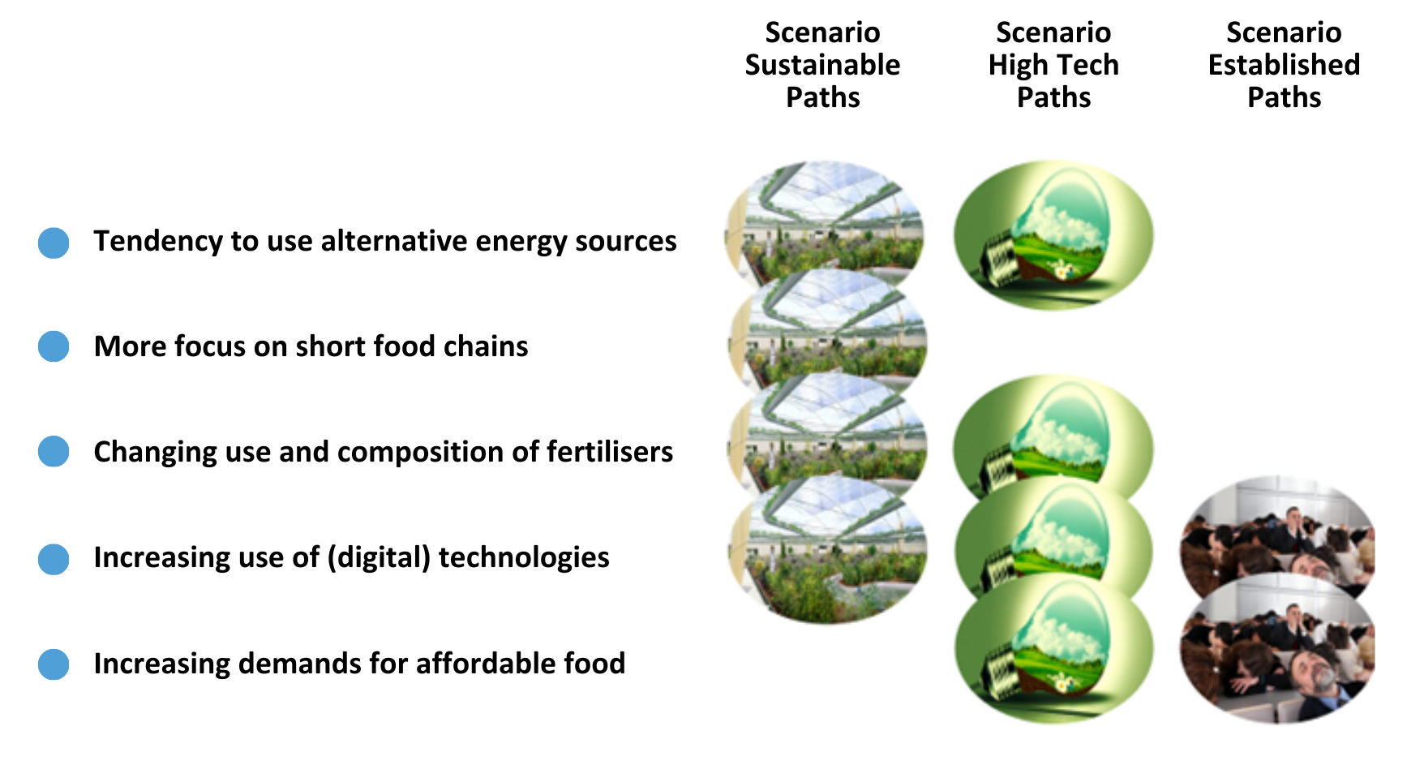Figure 5 How changing trends point in the direction of certain scenarios

However, as the figure shows, these new (or enforced) trends steer in the direction of more than one scenario. As most trends point at the sustainable path and high tech-path scenarios, it seems that the future agri-food and forestry system in the EU develops towards a combination of these scenarios.

Specification of skill needs
For the identification of skill needs in the areas Sustainability, Bio-economy, Digitalisation and Management, entrepreneurship and soft skills, FIELDS partners organised from May to July 2020 nine national focus groups (in Italy, Ireland, Spain-Portugal, Netherlands, Austria, Germany, Greece, France and Slovenia) and two pan-European focus groups on EU policy and on forestry issues (see for specifics on the methodology: Mayor et al., 2022; FIELDS D1.5 Focus Groups).
Remarkable to see was that the top 3 of the 10 most important skill needs as prioritized by the focus groups were management skills: business planning /model and strategic management, followed by two skills related to communication: everyday usage of digital technology to communicate and communication. Next in the prioritization came the technical skills, however, still with a managerial skill at position 8 (see figure 6)
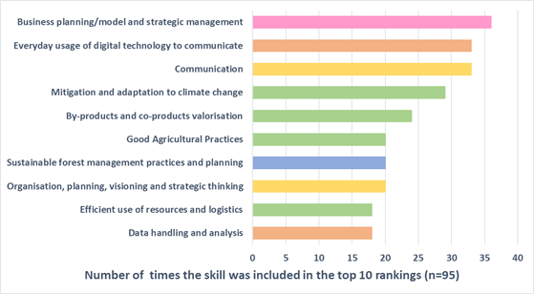
Figure 6 The most important skills as identified in focus group discussions at European level (FIELDS, D1.5 focus group discussions)

Considering the different types of stakeholders that participated in the focus groups, for farmers, cooperatives and also food industries business planning and strategic management and communication, everyday usage of digital technology to communicate were very important skills. For the forestry focus group, the sustainability skills and bioeconomy skills specific to the forestry sector were predominant.
As country differences in the sector structure, level of technology development, national policies, education levels etc. in Europe are huge, the results of the skill needs analysis differed between countries. Figure 7 shows as an example three country level focus group outcomes on key skill needs.
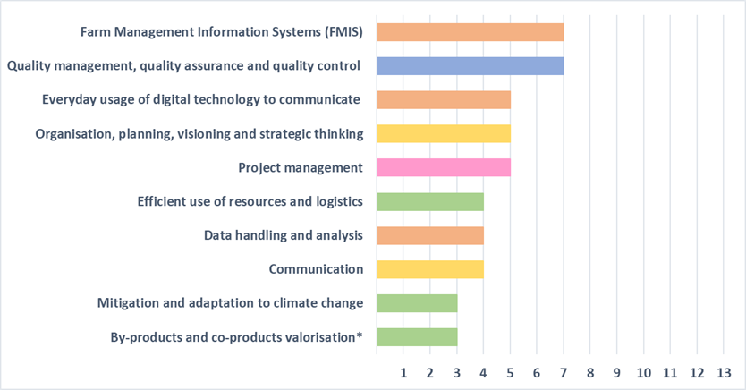
As figure 7 shows, the Italian focus group focused very much on skills that support company management, while the Irish focus group, next to management, focused more on (day-to-day) working practices. For the Spanish-Portuguese focus group, the attention to water management issues is most important.

Italy

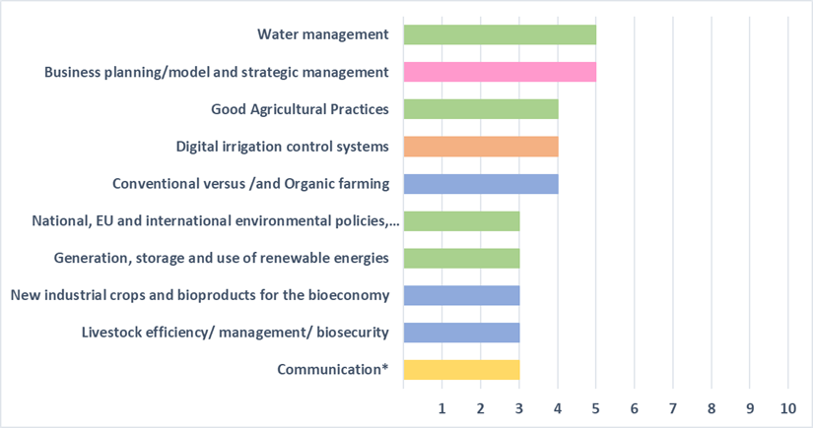

Spain-Portugal

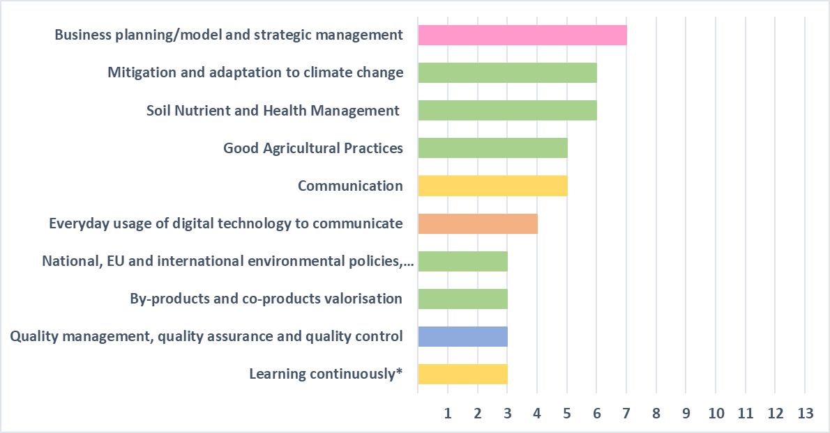

Ireland

Figure 7 Prioritised skill needs in three countries (FIELDS D1.5 Focus group analysis)
Spain-Portugal

Impact of recent trends on skill needs
The above-mentioned studies were performed in 2020-2021, and since that time there have been important developments in the social economic environment of the European agri-food and forestry sectors. Therefore, in the questionnaire of the second phase of task 2.3 we included several questions on the impact of recent developments on the trends in the agri-food and forestry sectors. In general, in line with earlier observations, Covid-19 was considered by most respondents a booster for digitalisation, the Ukraine war and energy crisis impact on shortages of energy and raw materials, the CAP 2023 additions reflect in increased demands on the Green agenda, and the increasingly apparent climate crisis in particular affect Southern European countries (droughts, forest fires). Then there were specific events in some countries, such as Brexit for Ireland, the deep economic crisis in Greece and recent regulatory changes in the organisation of the education and training system in e.g. Spain and Greece.
On the question of what the effects on skill needs of these developments are, the following was reported:
- Even more attention to skills related to digital literacy, bioinformatics, and cybersecurity skills
- Skills related to remote working and online teamwork, e-commerce, online learning
- Skills related to individual resilience, risk management and security of supply (materials, energy)
- Skills related to holistic thinking, knowledge of the whole supply chain, interdisciplinarity and cross-cultural competences
- Skills to understand and be able to apply upcoming applications of Artificial Intelligence, including Chat GPT
Underlining the demands on green skills and climate mitigation skills confirmed the importance of these skills as measured in the FIELDS focus groups. Country specific social-economic and regulatory developments in particular impacted the organisation of the VET system. In chapter 6 organisational issues will be discussed.

Labour market requirements and developments in VET systems

Labour market
According to the expert study: Promoting education, training and skills across the bioeconomy (EU, 2022), the expectations for the green labour market are the following:
- The employment in the overall bioeconomy will further decrease, in particular at farm level. In the primary sector, between 2020 and 2030 a further decrease of employment of 31.2% is expected
- Employment in traditional food manufacturing will decrease (-1.1%) whereas the biotech and biochemicals and bioenergy/bio-electricity sectors will show increasing growth numbers (resp. 21.8% and 15.5%). Pharmaceuticals and plastics will be the largest growers in this area.
- The share of employees in the bioeconomy with high level qualifications (EQF level 5 and higher) will increase from 16% in 2020 to 24% in 2030,
- The share of low level qualifications (EQF level 3 and below) will decrease, from 30% in 2020 to 25% in 2030. Medium level qualifications are projected to decrease from 54% to 51% in 2030.
In particular, sectors like food technology, biotech and bio-energy will attract more highly qualified employees. Similarly, in FIELDS like artificial intelligence, big data, robotics, advanced materials, and industrial biotech, quick adaptation of current skills and development of new skills will be required. In this respect, STEM-related competences are becoming more important (STEM = Science, Technology, Engineering, Mathematics). As Cedefop (2023) states: ‘Demand for people qualified in STEM subjects, especially those related to biology, biochemistry and chemistry, will increase; so will engineering and IT skills for farming 4.0 and continuous flow processes in food manufacturing. [However] Not only technical occupations (such as engineers, computer and data scientists, agronomists, biochemists, meteorologists and statisticians), but also sales and export -related occupations will become more important’. However, as the skill needs studies in the FIELDS project showed, next to technical skills, considered of high importance, are management, entrepreneurial and soft skills.
Another interesting trend identified by Cedefop (2023) indicates that towards 2030 employment in start-ups in the bioeconomy is expected to increase, implying that employment will be more diversified across a wider range of activities. This also may imply that the share of young people in employment will need to grow to accommodate this trend.
Finally, a trend is the further integration of adjacent bioeconomy related sectors, including farming, agrifood, forestry, fuel/energy, chemicals, pulp/paper and pharmaceuticals. This trend will ask for additional skills of employees and entrepreneurs across the bioeconomy, i.e. the ability to take inter-sectoral and cross-disciplinary perspectives if needed.

Supply of education and training
The green-digital transition will require a wide range of skills. In line with the findings in the FIELDS focus groups and Survey, the CEDEFOP expert study (Cedefop, 2023) finds that IVET needs to focus on expanding the provision of entrepreneurship and management skills, digital – data analysis and ICT skills – and technical skills powering sustainability practices. Moreover, empathy and human-centredness were also considered vital. The demands for wider ranges of skill needs are reflected in ongoing developments in education and training systems (Cedefop, 2022). In many countries, VET institutes broaden their profiles and increase their occupational scope and flexibility, going together with a reduction in the number of IVET qualifications. At the same time, VET curricula include increasingly general knowledge and transversal skills, also integrated in practical training.
An important challenge for most of the EU was underlined in the FIELDS Focus group study (D1.5 Focus group analysis), i.e. the lack of an organized lifelong learning system, meaning a system that connects learning across all ages and places of learning. As continuous learning is at least as important as initial training, the establishment of balanced and effective LLL systems is of key importance in all countries. In this respect, a promising development is observed by (Cedefop, 2022) where in a number of countries lines between IVET and CVET seem to be increasingly blurred. As in particular CVET asks for flexible and accessible education and training programs and courses, this development needs to be supported by short and easily accessible modules, and a quality and validation system of micro-credentials.
In line with these trends, the following promising developments in the current education and training system were mentioned by our respondents of the WP2.3 second phase survey:
- More attention is given to technological change, green energy, entrepreneurship and innovation skills
- The tendency to digitalization of learning and growth of the number of online courses is confirmed
- Attention for the One-Health perspective increases, including animal, human and environmental health and their interactions. As this is a rather new perspective, extra efforts in education and training are necessary
- The respondents see developments towards shorter training format/units (e.g. excursions, traineeships, MOOCs) and micro-credentials
- There is more attention to LLL training applications, also enabled by increasing digitalization and flexibility of working schedules and shorter training formats

Country differences in labour market and education and training supply
In section 2 (trend and scenario study) we already discussed some key differences between countries in the EU on technology development, sustainable production, business structure, etc. In our WP2.3 survey phase 1, related differences in labour market demands, job profiles and skill needs between countries were reported. Moreover, education and training systems differ across countries as well as levels of knowledge and skills, competence levels of trainers, etc.
Indeed, VET programs are usually adapted to regional and local circumstances and industries, with different labour markets, skill needs and definitions of job profiles. The national roadmap studies which were developed in FIELDS WP2.4 show a number of particular and topical challenges per country, underlining the differences in demand and supply of skills and the different political spearheads in these countries :
Finland | - Cuts in resources reflected by lower numbers of VET applicants.  - Lack of interest (employees and students) in forestry  - Labour demand in agri-food remains, leading to shortages in supply  - Large demand for digital and green transition skills
Spain | - Difficult job insertion of young and unemployed people  - Large differences between regions in (the funding of) education/training offer  - Many under-qualified and over-qualified people, a large skills mismatch  - In particular limited development of intermediate qualifications
Austria | - Weak connection between agri-forest businesses and advisors, and research facilities (in general a lack of coordination between research and practice)  - Better incorporation of agri-forestry specific research questions in the national RTI politics is necessary  - Limited multi-stakeholder exchange and collaboration
Italy | - Vertical and horizontal mismatch of skills  - Low levels of qualification (difficult to get young people in a job and reintegrate adults)  - Under-developed training standards (for a better match between skills demand and supply)  - Complexity of governance and regional differences
Ireland | - Low attractiveness of VET for young people and weak recognition of the value of training and education  - Difficult job insertion of young people and reintegration of unemployed adults  - Informal training and education appear to be more dispersed and not always well accessible  - No specific official entity to train manual workers
Table 4 Typical challenges in demand and supply of skills in 5 European countries

Regulatory framework and funding challenges

EU and country regulatory framework
In the task 2.3 second stage questionnaire, we asked for bottlenecks/requirements regarding the existing regulatory system. We gave the following key examples of regulations on both EU and country/regional level:

On EU level
- EQF (European Qualification Framework)
- ESCO (European skills, competences, qualifications and occupations)
- VET Council Recommendation from 2020
- EQAVET (European Quality Assurance Reference Framework for Vocational Education and Training)
- European skills agenda (and focus on LLL)
- Pact for skills
- Digital Education Action Plan
- The European Entrepreneurship Competence Framework

On national/regional level
- National qualification systems, system of credits, diploma’s, certification systems
- Relations (tasks, responsibilities) between government and education/training institutes
- Teacher and trainer competences and requirements
- Training and education boards
- Adult education and LLL
- Inclusion and gender equality, e.g. social farming, specific target groups
- Personal training account and other training grants

In the answers of the respondents, we recognize three groups of challenges: structural challenges, challenges in stakeholder relationships and policy challenges. Structural challenges include the complexity and rigidity of the VET system, transparency, and validity of the system and (limited) attention to key elements of the system, such as lifelong learning systems and, on program level, the development of micro-credentials. Challenges in stakeholder involvement and stakeholder relationships underline the importance of balanced collaboration and responsibilities of multiple stakeholders in the system. Policy challenges point at the need for strategy development in a number of countries and harmonization of the education and training system across countries (e.g. to enable mobility of students and employees throughout Europe). Table 5 provides respondent answers in these three categories.

Structural challenges
- the large number of qualifications and the complexity of the credits-diploma’s-certification system in several countries
- education and training systems are sometimes rigid and bureaucratic and not aligned with the needs of the industry
- the development, implementation, and validation of micro-credentials
- transparent modular lifelong learning systems are still immature across countries
- transparency and comparability of qualifications across sectors and countries
- the quality and validity of examinations and assessments
- inclusion and gender equality in education and training

Stakeholder relationships challenges
- stakeholder involvement in the development and maintenance of qualifications
- engagement with private businesses for apprenticeships and work-placements
- too little cooperation and coordination between different levels and types of education
- involvement of education institutes in policy-making at all levels
- balancing the autonomy and accountability of VET providers
- transparency and accessibility of funding mechanisms

Policy challenges
- lacking national skills strategies
- LLL strategies are still missing in many EU countries
- across Europe, VET ecosystems differ between countries and regions, including different regulatory systems and different funding systems. For example, the European Qualification Framework (EQF) and National Qualifications frameworks (NQF) operate at different levels. Moreover, not all countries have a NQF with learning outcomes for each qualification
- an integral system of degree recognition in the EU doesn’t exist, not only for higher education, but also for VET. As the world of work is highly dynamic, the flexibility of including new skills, qualifications and job profiles in the ESCO system (the multilingual classification of European skills/competences, qualifications and occupations) should be further enhanced.
- best practices exchange between education and training systems of different countries
- little flexibility for regions (e.g. accreditation of VET providers by regional authorities).

Table 5 Regulative challenges for the VET system

Funding
Figure 8 shows main funding mechanisms for upskilling and reskilling of the European Union for the period 2021-2025.
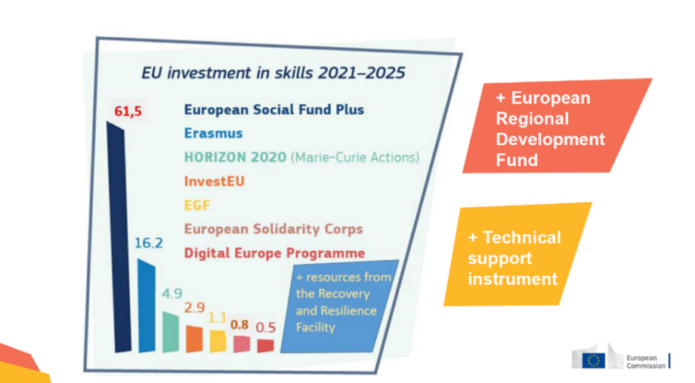

Figure 8 EU Funding Instruments for Upskilling and Reskilling

Table 6 gives a short description of these funding instruments.

- The European Social Fund Plus (ESF+) is the EU's main instrument for investing in people. https://www.eif.org/
- Erasmus+ supports the personal and professional development of learners, staff and institutions in vocational education and training and Higher Education (including European Universities). https://erasmus-plus.ec.europa.eu
- Horizon Europe underpins skills for researchers, entrepreneurs and innovators, notably through its Marie Skłodowska-Curie Actions. The Marie Skłodowska-Curie Actions fund excellent research and innovation and equip researchers at all stages of their career with new knowledge and skills, through mobility across borders and exposure to different sectors and disciplines. https://www.horizon-eu.eu/
- The InvestEU fund supports private and public investments in four policy areas which represent important priorities for the Union and bring high EU added value: sustainable infrastructure; research, innovation and digitisation; small and medium-sized businesses; and social investment and skills. https://investeu.europa.eu
- The European Globalisation Adjustment Fund (EGF), launched in 2007, helps people find new jobs through further education or training or helps them start their own business. https://www.euinnovationfund.eu/
- The European Solidarity Corps is an EU funding programme for young people wishing to engage in solidary activities in a variety of areas. These range from helping the disadvantaged to humanitarian aid, as well as contributing to health and environmental action across the EU and beyond. https://www.europeansolidaritycorps.nl/
- The Digital Europe Programme provides funding for the development of advanced digital skills and support the development of a talent pool of digital experts. https://digital-strategy.ec.europa.eu
- The Recovery and Resilience Facility can support Member States' reforms and investments, including in the area of skills and jobs. https://commission.europa.eu/
- The European Regional Development fund (ERDF) is designed to strengthen economic, social and territorial cohesion in the European Union. It aims to do this by correcting imbalances between regions, enabling investments in a smarter, greener, more connected and more social Europe that is closer to its citizens. https://ec.europa.eu/regional_policy/funding/erdf_en
Table 6 Key EU funding instruments for upskilling and reskilling

On the task2.3 phase 2 survey question to specify challenges in the funding system, the following image emerged. In general, it seemed that shortcomings are not so much in the quantity of funding, but in (new) content to be funded, in line with changing skill needs, and in the need for support of the (functioning and development of the) VET system. Moreover, the improvements needed in the accessibility of the funding system were underlined.

Table 7 depicts some spearheads mentioned in the task 2.3 phase 2 survey:

Funding of education and training content
- basic digital skills and digital skills as transversal skills
- management, entrepreneurship and soft skills
- a better combination of technical and transversal skills
- bio-based production as a new area of expertise (with currently insufficient targeted funding)
- a better definition of sustainability and biobased production skills and the establishment of specified funding programs (e.g. in forestry there is hardly any funding on this theme)
- funding for sustainability awareness
- funding for better inclusion of gender equality

Funding supporting the functioning of the VET system
- More permanent funding instead of a focus on funding on project basis
- Funding for continuous learning
- Funding for collaboration at EU level, e.g. for Pact for Skills
- Funding for more flexible and modular VET programs
- More funding for the implementation of a micro-credentials system (recognition, regulation, validation, training offer)
- Too little funding for work-based learning and business practice (in some countries)
- More funding necessary for education and training of advisors and technicians
- Funding to support professional development for educators and collaboration with industry partners
- Equipment and training for providers
- Funding for a better quality of internet connection (in some countries)

Accessibility of funding
- In most countries, national funding of education and training is via state funds. On both EU and country level, the accessibility of the funding systems need improvement, meaning better management and communication on what funding is available and for whom, and better guidance to apply.
Table 7 Challenges reported on the skills funding system
Concluding, the funding system needs to match better with current skill needs (sustainability, digitalisation, bio-based, management/entrepreneurship, inclusion, see preceding chapters). There needs to be more attention for funding that supports the functioning and development of the VET system, and the accessibility of the funding system for multiple stakeholders needs to be improved. Within these lines, specific requirements for the different countries and regions can be formulated.

Key requirements of training programs
In phase 1 of our task, the investigation of challenges and prerequisites of a European strategy for agriculture, food industry and forestry skills was undertaken by carrying out a survey among key stakeholders of the agri-food and forestry skills ecosystem (Trienekens et al., 2022 see annex 1).
Results differed quite extensively across respondents, probably dependent on background and region of the responding organisation and on the skill needs considered most important by individual respondents.

Key elements and prerequisites of VET programs
There were a number of key issues that respondents pointed out as key requirements for training programs:
A key position for management/entrepreneurship and soft skills
For the agriculture and food industry sectors several respondents stressed the importance of health and safety management, innovation management, (digital) entrepreneurship skills, critical and creative thinking, knowledge of agri-food communities, agro-tourism and local products. However, key attention was also given to relational skills, including staff networking and communication, negotiation, public speaking and English language, leadership and team management, food chain cooperation and interdisciplinary thinking.
Importance of training in practice
Working practices, working with real life problems and developing troubleshooting skills are essential for most training programs. Further, there is a need for excursions (e.g. in agriculture to experimental farms), demonstrations and lectures by people with hands-on experience. Specifically for the food industries, respondents reported practical training required around food safety and quality management, production operations, bio-based functions, and working with automation and digital applications on industrial sites. However, sectorial differences should be taken into account in processes and equipment (conveyor belts, mixers, packaging etc.), as different skills may be required. For agriculture several areas of the sustainability and bioeconomy dimensions were reported by the respondents as important in terms of practical experience, for example, waste prevention, soil health management and agro-environmental practices, production techniques for bio-based crops, industrial crops. Similar for forestry, digital skills and digital entrepreneurship, forest disease control and prevention, forest equipment/machinery and maintenance, and project management and business operations are important skills to be supported by practical experiences.
Next to these more technical skills, respondents in all three sectors underline the importance of practical experiences in communication skills, implying training of trainees in practical circumstances and supported by a company mentor. Moreover, working in a company implies collaboration with various staff functions, and not just working in and for one department (e.g. think of a lab function during a whole internship period).
Increasing importance of online learning
The Covid-19 pandemic has stimulated a further move towards online education at all levels of education. On the one hand this has led in the last two years to short term delays in training, as in particular practical exercises had to be postponed; on the other hand it has supported an ongoing trend towards online or blended (people are becoming ‘’zoom-tired’’) education, in particular in these countries and regions with sufficient digital infrastructure.
In general, for the more technical skills of the profiles on Bioeconomy, Sustainability and Digitalisation the basics can be taught online, however, advanced and applied knowledge/skills require in many cases practical training and real visits at factories, farms, forestry businesses. Moreover, new technologies like robotics and artificial intelligence, drones, cloud computing and blockchain as well as developments around data protection (regulations) and data privacy will require new skills, which can partly be taught online but which also need practical experience.
Online training is supported through the fast development of tools, such as virtual reality applications, video intelligence, 3D animation, simulation tools (e.g. how to manage machines or production lines), etc. In general online courses are better accessible and are wider available than in-class courses. However, engagement is often lower as, in general, interaction between teacher and trainees remains essential for many of the subjects. Therefore, for most modules a mixed approach is required. For these courses the ‘flipped classroom’’ approach can be applied, where online self-study and/or practice of students is combined with interactive classes.
For online training, basic digital skills and equipment are necessary. At the start of a course or module, digitalisation skills of trainees should be measured, as simple as possible, according to the requirements of that specific course or module. Depending on the level of skills of the trainee, (supplementary) courses can be offered. Customisation of educational procedures is a must in this regard, while training materials should suit a diverse EU population (language, culture, education level, urban-rural).
The right application of resources
Resources and in particular how to apply these are at the basis of any education and training program. This topic included questions on how to deal with lack of time and resources of potential trainees, how to raise interest for certain jobs and training and how to create ‘’inspiring learning environments’’. The answers of the respondents resulted in a long list of ‘’tools’’ that we grouped into four categories: timing, structure, communication and funding.

Timing
- Schedule courses in off peak time (evening, weekends) or in hybrid mode. In general, adapt time schedules according to the availability of the trainees.
- Divide courses in short lessons (e.g. <= 1 hour).
- Make modules/training courses complementary and diminish overlapping.
- Design tailor-made fast tracks for business management.
Program structure
- Include social entrepreneurship as a topic to learn trainees a ‘’sustainability mindset’’ with a long term vision on a sustainable bio-economy.
- Include hands-on experience and use real life cases and applications, showing connections with the newest technology. Bring in fun!
- Use technologies such as augmented reality and simulation; fascinating videos (e.g. of employees and of employers), game based resources, and online tools.
- Ensure that trainees serve in different departments during their traineeship so that they can get different experiences from different roles.
Communication
- Define clearly your learning outcomes.
- Organize active promotion at education institutes and at agri-industry meetings and platforms. Combine with campaigns: online, press releases, newsletters, leaflets, weblinks, etc.
- Emphasize the meaningfulness of jobs (supporting the production of healthy, sustainable and high-quality food).
- Modules and courses should be certified. Micro credentials should be offered, and trainees should receive formal certificates.
Funding
- Provide e-learning for free, via e-learning platform (doesn’t always have to include a certificate).
- EU programs, national funds and scholarships should be offered on competitive basis.
- Financial support of companies (for employees), private corporate and public scholarships for internships, compensation of training time, or sabbatical like approaches.
- Link subsidies to training certificate requirements (for example, organic farmers need to follow a 5-day course before they can achieve subsidy).
Table 8 Timing, structure, communication and funding tools

Attention to underprivileged groups and gender issues
Although, most respondents didn’t recognize any gender issues in the areas discussed, in all day practice some functions are gender related. As one respondent stated, ‘’.... forest management and wood science and technology are always believed to be FIELDS of men’’. In general, however, respondents report that gender should not play any role, therefore, existing European and national directives should be further put in place to overcome any existing job inequalities between men and women.
In particular relatively few women do have a leadership role in the industry, which needs attention, both in (tailoring of) training modules and in life-long learning courses. For agriculture, respondents mentioned special attention needs for female farmers and for decision-making functions at both farms and cooperatives. A special point mentioned regarding gender issues was the disadvantaged position of women after maternal leave. In line with this, reskilling of women who have been out of a job for years is a topic that needs attention.
Similarly, under-privileged groups and cultural diversity should remain a point of attention. In general under-privileged groups, low income workers and migrants might need financial support and support, through information and communication, to access courses. Next, labour mobility, migration and in particular seasonal harvest workers need extra attention in terms of language and adjustments in programs in terms of language and starting point.

Key performance indicators
Key performance indicators were defined at two levels, for the assessment of partnerships with multiple stakeholders and for the assessment of training programs up to individual courses (both groups applicable at EU and country level):
Table 9 Assessment of the skills partnership:
- Number of stakeholders actively involved
- Coverage of countries and regions, (sub-)sectors
- Visibility and awareness, public opinion, consumer opinion
- Best practice dissemination and willingness of partners to share information/knowledge
- Impact on training programs and interest for the training programs (number of interested participants)
- Employees actively interested in participating in Life-Long Learning
- Yearly growth rate of new courses
- Raised level of final degrees of food employees

Table 10 Assessment of training programs and courses:
- Number of students, company employees in the course
- Number or % of participants from underrepresented groups
- Achievement of learning goals
- Student evaluation of training content and method
- Number of certificates achieved
- Flexibility of programs (e.g. hours, ECTS, online/face-to-face, ...)
- Renewal of programs (new elements added year to year)
- Resources per program and course (e.g. human resources, financial, technology...)
- Weight of virtual, augmented and connected reality in the training modules, percentage of audiovisual learning vs class learning
- Employment status of trainees after graduation, incl. job promotions
- Trainees and employer job impact evaluation (e.g. better execution of tasks, increased salary, new employment)

Respondents were also asked for their knowledge of existing monitoring systems. This question resulted in limited responses, however.
Annex 7 gives examples of actual monitoring systems in Europe. In section 7 requirements for a monitoring system are described.

Training and education methodologies
FIELDS deliverable D3.1 on training methodologies distinguishes a number of training methodologies that may be considered in the design of learning programs, depending on the aim of the program, the target group and the trainer’s experience:
- Online learning,
- Microlearning (small and detailed learning units),
- Gamification (use of game dynamics in education),
- Flipped classroom (higher levels of Bloom’s taxonomy in classroom),
- Blended learning (combined classroom and e-learning),
- Peer learning (among members of a peer group with central position student),
- On-farm demonstration activities,
- Action-based and participatory learning.

This overview underlines our findings on innovations in training and education methodologies toward online learning, more attention to learning/training in practice, and increasing the attractiveness of education and training for students (‘’making learning fun’’) through new learning methods such as gamification, demonstration activities, etc.

The important trend towards more interest in micro-learning is reflected in the Council of the European Union adoption of the ‘’Recommendation on a European approach to micro-credentials for lifelong learning and employability’’ (16 June 2022). The approach is to stimulate lifelong learning, build trust and enhance flexibility of training/learning. The Erasmus+ project I-Restart has one of its focuses on the further development and implementation of the micro-credentials approach, and thereby continues on results of the FIELDS project.

Organisational directions: towards a balanced governance structure of the European skills ecosystem

Introduction
In this chapter we develop a framework for the analysis of the governance structure of the European skills eco-system.

The governance structure of the European skills ecosystem is subject to continuous changes, through EU as well as through country policies. An important stimulus for change is the exchange of knowledge and best practices between countries, often stimulated through EU policies and EU funded projects.
In the nineties of the last century, 3 types of skill governance systems in Europe with different stakeholder roles were distinguished (Greinert, 1998):
- State-driven governance model (e.g. France, Sweden). The system is regulated by the administration and based on the logic of school operations. The company’s role is limited to providing internships
- Market controlled governance model (e.g. UK). System directions are in the hand of employers and the labour market. Training in particular takes place on the job and in private institutions
- Corporate governance model (e.g. Germany, Austria, Switzerland, Netherlands, Denmark): mixed system of cooperative governance, based on social dialogue. Regulation takes place in a pluralistic network consisting of state bodies, companies and business associations, trade unions and professional organisations.
This classification shows the diverse nature of the management of the skills systems in the EU countries at that time.

However, in the last decades we see significant changes in the governance of the European skills ecosystem, although routes taken differ per country. Kingston and Caballero, 2009 (CEDEFOP, 2022) distinguish 2 paths of institutional change, through:
- a centralised system where institutional change occurs from a central organisation (e.g. the Ministry of education). This is a rule based system of change (through legislation, policy directives)
- an evolutionary, decentralised system, where new institutions arise and compete with existing ones, ultimately leading to a new institutional equilibrium

According to an in-depth study of the European education and training system (Martinez Izquierdo, Torres Sanchez, 2022), the overall approach of the EU government goes into the direction of an evolutionary, decentralised system, i.e. fostering a more pluralistic governance system, where cooperation among stakeholders in the design, management and financing of the system is strongly promoted, enhancing social dialogue and supporting skills ecosystem dynamics by strengthening responsiveness to change.

In a pluralistic system multiple interdependencies between actors with different (social-cultural) perspectives exist. It is characterized by a multi-level governance structure, with a variety of geographical and organisational scales, involving a range of actors with different authority and responsibilities. Accordingly, design, planning and implementation implies multi-stakeholder involvement in negotiating, decision-making, policy implementation and delivery of services. Cooperation at micro-level (between schools and employer, or teacher and company) will be at the basis of the system. With respect to funding, a pluralistic system implies multi-actor responsibility. For example, in the VET system both public and private partners are responsible for funding, there is co-investment for apprenticeships and adequate remuneration and social protection for apprentices. However, also effective use of structural funds to support VET reforms at national level (including fiscal incentives and subsidies for companies) are of eminent importance.

As we will see further in this chapter at national level in many countries still most of the change comes from central organisations, in particular the government (e.g. ministry of education). Though, in most of our example countries we do see a move towards a more evolutionary and decentralized system. Still, the skill ecosystem’s governance approach of a country is contingent on sector characteristics, history, and culture (Siekmann and Circelli, 2021). Therefore, we found important differences between countries. Despite these differences, however, there seem to be typical success factors for the creation of a new pluralistic VET system, that hold across countries:

- the establishment of national and regional sectoral skill platforms or councils to strengthen partnerships between employers, training/education institutes and the government
- the identification of change agents to bring policies into practice (e.g. associations, coops, technology/service providers, social partners) (see also Opendei, 2022)
- the strengthening of local partnerships between employers and training providers
- cultural and behavioural change (e.g. through communication strategies, subsidies, training and education)

VET Organization and change in various countries
Although autonomy of institutes is restricted in most countries, as far as qualification system, overall curricula set-up, and apprenticeship system is involved, schools do have in many countries their own responsibility for the inclusion of industry and region specific elements in the education and training programmes. The same holds for institute-company collaboration with regard to workplaces and apprenticeships for students. Decentralisation tendencies, with more autonomy for individual institutes were reported from Austria, amongst others to create a more diverse and regionalised system, and Portugal. In Italy and Finland, there is a tendency to specialisation of individual institutes, mostly due to significant investments required for teaching facilities. In Italy this goes together with increasing autonomy in the set-up of training programs, application of resources, collaboration with (local) companies, and choice of target groups. Similarly, in several countries (Ireland, Spain) there is a quick growth of private VET institutes, which enforces specialisation tendencies. In countries like The Netherlands and Ireland, we saw concentration tendencies in the last decade with schools merging into larger institutes. Although in most countries, teachers independently create learning materials and try to increase collaboration with (local) companies and apprenticeships, autonomy of individual schools seems to be under pressure in these two countries.

The responsibility for design of VET in many countries is in the hands of the responsible ministries, although there is room for the input of multiple public and private stakeholders. Stakeholders have influence on the processes of VET design, by participating in VET design working groups and other forms of collaboration. Some countries have made a step further towards public-private collaboration in VET change processes, by allowing multiple stakeholders to autonomously investigate, propose and initiate VET change processes. For example, in Austria, 5 main stakeholders can play this key role (Chamber of commerce, Federal ministry (BMDW), IBW- institute for research on qualifications and training, employee organisation (AK/OGB) and the Federal Vocational Training Advisory Board (BBAB)). Another example is Finland with the ‘Skills Foresight Forum’, incorporating a wide range of stakeholders that can play a key role in these change processes, although the Finnish National Agency for Education ultimately reforms the VE system.
Although, we see in many countries a move towards multi-stakeholder collaboration in the design and implementation of VET system changes, several respondents pointed at serious obstacles for a fast success:
- fragmentation of the system and lack of coordination,
- diverse stakeholder interests and competition,
- differences in values of stakeholders,
- time and funding challenges.

Furthermore, because of these obstacles regulatory processes before a new curriculum is adopted are long, while technology and labour market demands advance quickly. On the question of which are the most important change agents in the development of the VET system in the country, respondents put on the first-place farmer or industry organisation (Germany, Italy, Finland), labour organisation (Greece), business-education organisation - CIV (The Netherlands), Federal economic chamber (Austria), government (Greece, Portugal). Although this pictures diversity in the position of change agents throughout Europe, for most of the respondents most important change was considered to come from non-governmental organisations.

Work-based training/learning (e.g. through apprenticeships) is a key element of VET programmes and is recognized as indispensable by all respondents. The organisation, financing, student-company interaction and formality of work-based learning, however, differ from country to country while also in most countries different systems exist alongside each other. In this report, some of these differences will be explained. For more information on apprenticeship systems we refer to FIELDS D3.3, Apprenticeship scheme report and

In the below box, the two main systems for work-based learning in Finland and in Ireland are described.

In Finland, the training agreement is a type of work-based learning (WBL) that can be offered in all initial and continuing VET programmes. Learners are not in an employment relationship with the training company. They do not receive salary and employers do not receive any training compensation. Then there is the Apprenticeship training contract (any qualification can be acquired through apprenticeship training) – a work-based form of VET that is based on a written fixed-term employment contract (apprenticeship contract) between an employer and an apprentice (Eurydice, 2023).
In Ireland, there is a two tiered system for apprenticeships. Tier 1, Consortium based (industry), the apprentice is paid for by the employer, for both on-the-job training and in-education training periods, thus the cost for the employer is very high. Tier 2 on the other hand (Crafts), the apprentice gets an apprenticeship allowance from the government, whilst they are in the in-education periods of their apprenticeship. In this case the employer only has to pay for the on-the-job training periods, making it more attractive for employers to get involved in the apprenticeships scheme.

The organisation of the contact between student and company also varies across countries. For example, in the Netherlands there is an online nationwide database with internships, open to all VET learners from all sectors, while in Finland the connection between company and student is organised through a regional apprenticeship operator, and in Ireland companies have personalized agreements with certain educators for the establishment of student company connections, these are not open for reasons of competition.
In most countries, funding of apprenticeships is through public funds, although companies contribute through covering training costs and social security. Many countries have a system of remuneration for apprenticeships varying from: none or a limited allowance for e.g. transportation and meals (e.g. Portugal), according to established business norms (e.g. Italy, apprenticeship is an open-ended employment contract), the obligation to pay wages or compensation based on negotiations between student and company (e.g. France), to payment of wages according to collective agreements (e.g. Germany, Finland, Austria). In some countries, like The Netherlands (2023), Greece (2016) and Spain (2022) recent legislation moves towards regulated remuneration of apprenticeships, often related to collective labour agreements in the sector.

In Annex 8, a description of the VET (governance) system of five example EU countries, based on the information of survey respondents (task2.3 second phase) and Cedefop country reports.

Governance functions
In this section, we go into the division of governance functions between EU and country level. In our questionnaire we included questions on typical governance functions of the VET ecosystem that should be executed at EU level and at country level. Taking the key functions as defined for the Pact for Skills as references (https://pact-for-skills.ec.europa.eu), we distinguish 6 governance functions: Networking (hub), Knowledge (hub), Guidance (hub), Communication services, Monitoring services, Management activities.

Below, the views of the respondents on how the above-mentioned governance functions should be filled in at EU and country level are described.

- Networking Hub. According to most respondents there should be a network function at both EU and country level. At EU level there are Erasmus+ program like functions, EU research projects and the building of connections and partnerships between national VET/institutions and stakeholders, such as performed by the recently established Agri-Food Pact for Skills, and/or the possible set-up of an international forum to address education and training issues. Partners point also at the importance of collaborations between networks such as EVTA, EfVET, EVBB, eucen, EURASHE through the VET4EU2 partnership. Other examples are the VET week and a series of VET related cross-national working groups. The coordination between these networks and with EU level organisations for VET should be further improved though, in particular for the agri-food sector. However, as some respondents point out, the network function at EU level is restricted. Most important is, at a more operational basis, networking at national or regional level between the various public and private stakeholders of the VET ecosystem, in order to tackle topical issues and challenges, to build (regional) partnerships, maintain communities of practices, disseminate the use of tools, and to set up projects for explorative reasons.
- Knowledge Hub. At EU level a key function is considered coordination of best practices exchange and sharing of tools and expertise between countries and regions. This function might be organised as a central repository of VET best practices and innovative approaches in VET. Additionally, the function can actively support exchange of best practices though a supportive web function and by (e.g. yearly) meetings, workshops, seminars, proactive tools sharing, etc.
At national level these knowledge exchange functions are even more important and go a step further than the mere coordination of exchange, such as at EU level, i.e. towards supporting the actual implementation of best practices. With regard to this National Expertise Centres (or Centres of excellence) might be useful, for the organisation of workshops and training sessions and organise dissemination through seminars and other meetings. To achieve a solid exchange of knowledge and practices throughout Europe, good connections between the EU- and the national Knowledge Hubs are essential.
- Guidance Hub. An EU level guidance hub can support the development of the Agri-Food Pact for Skills, advise on National Skills Strategies, provide information on available funding mechanisms, assist in the setup of Centres of Vocational Excellence, establish quality assurance mechanisms and facilitate the implementation of EU policies. Apart from the stimulation of cross border partnerships, e.g. linked to the exchange of best practices, guidance in the establishment of partnerships is in particular a function at national level, as needs are often region, sector and project specific. At national level, a guidance hub to set up and link partnerships between VET and supply chain partners is extremely important. It supports developing effective VET programs, stimulates quality assurance, and identifies concrete funding opportunities.
- Communication services. Website and communications tools at EU level, for effectively disseminating information and maintaining communication channels within the EU VET ecosystem, are very important. Communication services are in particular supportive to the other EU governance functions. As communication is strongly tied to culture, implementation at national level is very meaningful. National communication services should focus on national opportunities for training and education, while providing information on regional and/or local relevant outcomes.
- Monitoring services. A monitoring service at EU level is useful if it bundles data from national monitoring services, comparably, to enable targeted EU level support and policy initiatives. A more specific task for the EU may be quality assurance of monitoring as this takes place across countries, to make data gathering, impact measurement and data analysis comparable. A tool, with a good cost-benefit ratio, can be project based monitoring (e.g. two yearly cross-country surveys). At the same time, however, a better interconnection between the data collection functions of the EU is needed (Cedefop, Eurofound, European semester). In general, this function should remain a key function of the Commission’s DGs and the different EU agencies.
As EU level monitoring will be on a relative high abstraction level, with assessment of a limited number of indicators, national and regional monitoring will be relevant to monitor performance and effectiveness of the VET system (demand and supply of skills and policy impact assessment). Monitoring services at national level are, therefore, indispensable. However, quick and easy to understand measurement instruments, which are flexible and financially sustainable are needed (‘less is more’).

Important for the right connection between EU-level and national/regional monitoring systems is, as explained above, the identification of a common methodology for monitoring skill needs and the commitment of member states to provide feedback. That is why it is so important to design easy to manage and workable, non-time intensive, low complexity monitoring systems at both levels.
- Management activities. Management activities at EU level may aim at standardizing the level of support, to stimulate stakeholder engagement through the set-up of EU working groups, to support international apprenticeships and mobility of learners, and to coordinate work programs.
At national level specific tasks are organisation of stakeholder engagement in the industry and VET education, build work programs, allocate resources and foster partnerships.

Key with regard to these governance functions is that their ultimate objective is to support design, development and implementation of a VET ecosystem on the ground, i.e. at regional and local level. Thereby, the requirements at the local/regional level should be leading for any organisational function at both EU and country level.

Table 11 depicts a summary of main governance functions at EU and country level.

Function | EU-level | Country level
Networking hub | Networking for coordination of EU level VET organisations and strategic partnerships between multiple stakeholders from various countries | Networking for partnerships building (tactical, operational) and VET implementation at national and regional level
Knowledge hub | Coordination of exchange of best practices and tools between countries. Design and implementation of a best practices and knowledge repository | Exchange and (joint) implementation of best practices and tools at national and regional level (e.g. through national expertise centres)
Guidance hub | Pact for skills development, support of national skills strategies, setup of expertise centres throughout Europe | Guidance in setting up national and regional multi-stakeholder partnerships (between VET and supply chain partners)
Communication services | Supporting network, knowledge, guidance and monitoring functions through multimedia infrastructure and tools | Communication of training and education opportunities, funding opportunities, VET outcomes and development at national and regional level
Monitoring services | Monitoring general trends in supply and demand of skills, impact assessments and comparison between countries. Support design of monitoring systems. | Monitoring the performance and effectiveness of the VET system, focusing on supply and demand of skills and national/regional policy impact assessment. The focus is on skills learning and application.
Management services | Standardizing level of support to countries, stimulate stakeholder engagement at EU level | Organisation of VET-industry stakeholder collaboration, supporting partnerships and VET implementation
Table 11 Main governance function in the EU skills ecosystem

Conclusion and key strategic directions

Introduction
This chapter will conclude with a number of key strategy statements based on the previous chapters.

In the FIELDS project, task 2.3 we design a European level skills strategy for the agri-food and forestry sectors. This strategy is in line with the European Skills Agenda of the European Committee (EU, 2020). The European Skills Agenda is a five-year plan to help individuals and businesses develop more and better skills and to put them to use, by:
- strengthening sustainable competitiveness, as set out in the European Green Deal
- ensuring social fairness, putting into practice the first principle of the European Pillar of Social Rights: access to education, training and lifelong learning for everybody, everywhere in the EU
- building resilience to react to crises, based on the lessons learned during the COVID-19 pandemic
- to address digitalisation inequalities
- to find balances between EU, national, regional and local levels, across the whole EU
The agenda is supported by many ongoing EU initiatives, such as the Pact for Skills with a key role in supporting the European skills ecosystem, various initiatives to enhance digitalisation efforts in different sectors, and others (EU, 2023a, EU2023b).

Next to the supply of skills by (vocational) education and training institutes, labour market demands for skills and the corresponding training needs are at the basis of European policies. As the FIELDS focus group report on European policy states: ‘In the agri-food sector there is a lack of understanding of the current skill challenges faced by employers and employees: the “Social Dialogue” should be strengthened, fostering communication between the employers and employees, at both EU and member states level, on relevant topics such as how to train the current workforce’ (FIELDS D1.5).

The approach of the EU Skills Agenda is supported by the findings of the Erasmus+ FIELDS project. The project has led to new insights in the European agri-food and forestry skills ecosystem. Key trends in the areas of digitalisation, sustainable production, bio-based production and business models have been identified. However, trends are continuously evolving, making a solid prediction of the future agri-food and forestry sectors extremely hard. For example, in the last years, because of the Covid-19 pandemic, the energy crisis and the Ukraine war, we see a further increase in the use of new (digital) technologies to cope with labour shortages, and also to be better able to deal with the uncertainties of the international food chain. Supply and demand uncertainties ask for resilient international food chain partners and, at the same time, transparency of these chains. Supply uncertainties and the ongoing energy insecurity in the chain have also resulted in a growing interest of agri-food and forestry companies in short food chains and of consumers in regional products. More efforts are also made in the formation of alternative energy sources, resulting in alternative business functions and market relationships. Moreover, apart from these developments, we see also increasing attention for alternative and new foods, local diets and personalized food. Finally, because of the social economic crises and rising food prices, there is an increasing lauder call for affordable food.

Because of the impossibility to predict the future agri-food and forestry system we designed three scenarios: the High Tech Path scenario (where the focus of the system’s stakeholders is on technology solutions for the current challenges), the Sustainable Path scenario (where the focus is on solutions through sustainable production systems), and the Established Path scenario (where current approaches to cope with the challenges are pursued). However, given the recent trends we concluded that solutions are to be found in a combination of high-tech and sustainable production, where, again, a key requirement is for affordable food by a large share of the European population.

Skill needs and training offer
One finding of the trend analysis were the huge inter-country differences in the dimensions of our study. The differences between countries stand out and are dependent on key characteristics such as digital infrastructure, level of sustainable production, farm/company structure, industry developments, level of education, etc. These imply differences in skill and training needs and education and training policies between countries. In the same way different scenarios imply different skill needs (according to digitalization and sustainability of the production system, specific business model, consumer and supply chain relationships), training needs (according to labour market demand), sector policies (e.g. regionally versus internationally oriented), education and training policies (e.g. centralized versus decentralized), and the role of the private sector in VET (e.g. company-school collaboration and private investments).

In the extensive skill needs analysis in the FIELDS multi-country focus group study and survey, a remarkable finding was the top priority of management skills: business planning, strategic management, everyday usage of digital technology and others, next to the demand for (new) technical skills in digitalisation, sustainability and bio-based production. Linked to the management and business skills, the importance of soft skills was underlined. Corresponding with earlier observations, Covid-19 was considered by most respondents, of the WP2.3 second phase questionnaire, a booster for digitalisation related skills. The Ukraine war and energy crisis enforced the requirements for skills related to the use of renewable energy and new materials, and skills related to resilience and risk management. The CAP 2023 additions reflect increased demands for sustainable production skills. Overall, skills related to interdisciplinary and holistic thinking are becoming more important.

In general, the European education and training system follows these trends, but implementation of changes is, understandably, lagging behind. According to the respondents in the training programs, more attention is given to technological change, green energy, entrepreneurship, innovation skills. And, there is the tendency of digitalization of learning, developments towards shorter training formats, more attention to livelong learning (LLL) applications and a growing interest in micro-credentials. However, differences in labour market demands, job profiles and training programs between countries are obvious. Indeed, VET programs are usually adapted to regional and local circumstances and industries. Particular and topical challenges per country underline the differences in demand and supply of skills and the different policies in these countries.

Strategy statement 1: training needs
The focus of training programs should move to skills as measured in the FIELDS project and related projects. As skill needs in the agri-food and forestry sectors are continuously evolving, training programs should be flexible and easily adaptable to latest trends. Future needs move in the direction of skills for sustainable production, high-tech skills (for sustainable production and the production of affordable food), and management/entrepreneurship and soft skills to cope with a dynamic and interlinked business environment. Within these frameworks, specific requirements for the different countries and regions can be formulated.

Regulatory system and funding
Our study pointed out a number of challenges in the enabling regulatory system. We recognize three groups of challenges: structural challenges, challenges in stakeholder relationships and policy challenges.

Strategy statement 2: regulations
Structure: at EU level harmonization of skills, qualifications and job profiles is of great importance. At the same time flexibility of EU level systems such as ESCO should be enhanced, due to the dynamics in supply and demand of skills. Overall, there should be a focus on decreasing complexity and rigidity of current VET systems, transparency should be increased, and attention to key, currently undervalued, elements of the ecosystem, including lifelong learning systems and, on program level, the development of micro-credentials should be increased.
Stakeholder involvement: the move towards multi-stakeholder involvement in the design, planning and implementation of VET systems must be (further) enforced.
Policies: country level skill strategies should be developed and maintained in all EU countries. Harmonization of the education and training system across countries (e.g. to enable mobility of students and employees throughout Europe) should be a key objective at European level.

Regarding the challenges in the funding system, we make a distinction between funding of education and training content, funding to support the functioning of VET systems and funding to improve the accessibility of these systems.

Strategy statement 3: funding
Content: the funding system needs to match better with current and evolving skill needs (sustainability, digitalisation, bio-based production, management/entrepreneurship and soft skills.)
Support and maintenance of the VET system: more permanent funding instead of project funding, funding for EU collaboration efforts (e.g. Pact for Skills), funding to enhance flexibility of education, funding to enhance inclusion and equality, funding to support teachers, workplace-based learning, VET infrastructure
Accessibility: the accessibility of the funding system for multiple stakeholders needs to be improved through more transparency of the funding system, better communication and guidance of (potential) applicants

Within these frameworks, specific requirements for the different countries and regions can be formulated.

Key elements and prerequisites for future VET programs
In this study (first stage questionnaire and second stage of the study), key elements and prerequisites for the development of future agri-food and forestry VET programs were identified.
Strategy statement 4: key elements and prerequisites for future VET programs
- attention to lifelong learning should be further enforced. There is the tendency described by (Cedefop, 2022f) that boundaries between IVET and CVET are increasingly blurring. In this regard, micro credentials may further influence the integration of IVET and CVET.
- in training of management/entrepreneurship and soft/transversal skills, besides to general business planning and management skills, key attention should be given to relational skills.
- working practices and work-based training are essential for most training programs. This in particular holds for the more technical skills, although typical skills to communicate and collaborate with other functions also do need practical experience and guidance by company mentors.
- in the design of new courses an optimal balance between online education (e.g. flipped classroom), face-to-face education, and in-company practice should be strived for.
- besides the necessity to improve internet access and access to computer equipment across Europe basic digitalisation training courses should be developed throughout Europe.
- under-privileged groups, low-income workers and migrants need financial support and advice to access training.
- gender issues should be pre-assessed, in particular in training for tasks that are considered ‘’masculine’’ or ‘feminine’’, and in soft skills modules. Special attention must be paid to women job returnees (upskilling)
- in the design of modules and courses, specific attention should be paid to 1. timing (align the course schedule to the trainee’s availability), 2. structure (the aim is learning for practice), 3. communication (on the benefits for the trainee), 4 funding (to enable participation financially).
- In general, trends towards the increasing importance of high tech skills, sustainability skills, and management/entrepreneurship and soft skills converge across European countries. However, important parts of the VET training offer will be different according to specific characteristics and requirements of countries and regions. Therefore, standardization of training modules across Europe is difficult and training standardisation possibilities should be investigated on the level of ‘’basic’’ modules and/or courses.
These elements and prerequisites are largely consistent with the EU 2020 VET Recommendation, that called for VET programmes to be: ‘’learner centred, offer access to face-to-face and digital or blended learning (and) flexible and modular pathways based on the recognition of outcomes’’(CEDEFOP, 2022f).

Governance functions in the future VET eco-system
In this section we first investigate the governance rationale of the European skills ecosystem by referring to the well-established concepts of Exploitation and Exploration (March, 1991). Exploration of an organisation refers to redefining or adding new objectives, finding new pathways and business processes, creating or tapping into new resources. Exploitation is making efficient and effective use of the resources at hand to reach the organisation’s objectives. Exploration can be linked to terms such as search, variation, risk taking, experimentation, play, flexibility, discovery, innovation. Exploitation to terms such as refinement, choice, production, efficiency, selection, implementation, execution.

In relation to governance of the skills-ecosystem, exploitation is very much related to execution and implementation of education and training and would fit best with national and regional tasks in the skills ecosystem. Though, also at this level continual exploration is of great importance, in a dynamic and fast changing labour market. At EU level, exploitation is a less obvious function, although tasks related to overall control of (efficient) use of resources and selection of EU level targets are clear functions. More important roles are to be found in the coordination of activities by facilitating networking between stakeholders through partnership and platform building, and to organize interactions between actors, e.g. for the dissemination of best practices or for joint reflection and support of innovation.

Key with regard to the governance functions is that their ultimate objective is to support design, development and implementation of a VET ecosystem on the ground, i.e. at regional and local level. Thereby, the requirements at the local/regional level should be leading for any organisational function at both EU and country level.

Strategy statement 5: key governance functions in the European VET eco-system
EU-level key functions: exploration and high level exploitation
-Networking for coordination of EU level VET organisations and strategic partnerships between multiple stakeholders at EU level. Support of policy making efforts
-EU level coordination of exchange of best practices and tools
-Pact for skills development, support of national skills strategies and set up of expertise centres across Europe
-Coordinate VET supply and demand monitoring efforts, make high level inter-country comparisons and EU policy impact analyses
Country-level key functions: exploration and exploitation at VET implementation level
-Networking for partnership building and VET implementation at country and regional level
-Exchange and (joint) implementation of best practices and tools at national and regional level
-Setting up national and regional multi-stakeholder partnerships (between VET and supply chain partners)
-Monitoring the performance and effectiveness of the VET system, focusing on supply and demand of skills and national/regional policy impact assessment.

Strategy statement 6: Monitoring in the European VET ecosystem
Because of the diversity in the agri-food and forestry skills ecosystem across countries and the rather scattered and incomplete monitoring initiatives, support of design and harmonization of agri-food and forestry monitoring systems is an important task at EU level.
Key performance indicators (KPIs) can be used for monitoring progress and outcomes and to take decisions on the way to go forward. KPIs are needed for ongoing assessment of the skill partnerships (Pact for Skills) and for assessment of training programs and courses. However, a system of KPIs should be limited in complexity, and be transparent and user-friendly. At European level, monitoring of the agri-food and forestry skills ecosystem should be based on a limited number of KPIs, to assess general trends in the demand and supply of skills and general policy impacts. At country level, monitoring focuses on these areas of the skills ecosystem and these indicators where policies are meant to have an impact. As different countries will have different interests regarding the formulation of KPIs, data collection methods and depth of analysis, harmonization efforts should focus on only these (few) indicators that are necessary to make high level comparisons at EU level. The EU and country level systems should be smart, user-friendly, upgradeable and interoperable. The many examples of monitoring systems working on national and multinational level can be the starting point of the development of a European skill monitoring infrastructure. European-level organisations such as Cedefop could be responsible for the EU level data collection and analysis, or through an instrument such as periodic (e.g. two-yearly) surveys.

Use of this report and further steps
This European Strategy report will be used:

- as a framework for the national roadmaps to be concluded in task 2.4 of the FIELDS project
- as a framework and starting point for the skills strategy to be developed in the Erasmus+ I Restart project, where the focus will be on the animal production sector, the veterinary sector, and the food industry
- as input for the discussions on the tasks, activities and organisation of the Agri-food Pact for Skills, established in 2022
- as input for discussions on the future European VET ecosystem with multiple EU and National level stakeholders

Annex 1 Task 2.3 Phase 1 methodology and questionnaire
The questionnaire included the following topics:
- Prerequisites for the development of training programs
- Harmonization challenges in the European agri-food and forestry skills ecosystem
- Monitoring and key performance indicators the European agri-food and forestry skills ecosystem
- Partnerships in the European agri-food and forestry skills ecosystem
The selection of these topics was based on EU policy documents and reports of EU level organizations involved in the analysis of skill needs and/or the design of training. (DigCompEdu, 2021; EU, 2021c/2021d; EU, 2018; Cedefop, 2020; EU/EACEA/Eurydice, 2016; EU, 2021e; EU, 2020) and reports of EU level organizations involved in the analysis of skill needs and/or the design of training (Effat/FDE, 2019/2020; EfVet, 2019; LLL, 2020 a/b/c; ILO, 2019). This information was complemented by a series with two-weekly discussions from april-october 2021 with FIELDS project partners. The questionnaire was semi-structured.
All stakeholders approached were partners of the FIELDS project, except for two forestry related respondents who were added to receive sufficient response for this sector. Respondents were asked to focus in their answers on one domain: agriculture, food industry, forestry. The questionnaire was sent out in the first week of October 2021, responses were received until mid-November 2021. 25 out of 30 stakeholders approached sent in their response: 14 focusing on the agriculture sector, 7 focusing on the food industry and 4 focusing on the forestry sector. The results of the survey were pre-discussed with a group of experts from agriculture and the food industry, and were qualitatively analyzed. Answers were first grouped (in excel files) according to sector, job profile and key topic in the questionnaire. Subsequently further analysis was based on the key topics, sometimes rearranged or grouped if necessary. In the final analysis results from different sectors and research dimensions (e.g. sustainability, digitalization) were combined, as for a number of topics no differences between sectors and/or research dimensions had been identified. When necessary, however, differences between sectors and/or research dimensions were articulated.

Questionnaire FIELDS D2.3 survey part 1
Please insert your answers, in different color letter type, below the related question. (Even if you are not an expert on the topic, your opinion/insight will be valued!!)

Training modules
- What specific training modules (coherent groups of skills) do you recognize in the job profiles? (NB in this questionnaire one job profile includes more than one training module, where we focus on the essential skills and essential knowledge)
- What are key management/entrepreneurial and soft skills fitting with a certain job profile and training modules? (please use the skill list from the ‘’Basic Module for each occupational profile’’ as defined in WP2.1)
- For which training modules (coherent groups of skills) is practice most important? How to connect to working practice? What role do you see for apprenticeships?

Target groups
- What would be the most important business functions in your sector (not the identified job profile) that could gain from the different training modules?
- Can you identify specific target groups (e.g. age, education level, cultural background, ...) for these training modules? For which target groups the identified training modules are essential for job retention (i.e. through upskilling)? Can you give examples?
- For which training modules gender issues play a role (access to training and/or jobs because of cultural values, ....). And with respect to underprivileged groups you are aware of?
- Do social and demographic change (aging of workers, labor mobility, increasing number of migrant laborers) impact on the training modules distinguished? How to take these effects into account?
Resources
- How to deal with lack of time or funding of potential trainees? (if possible please give examples for training modules as identified).
- How to raise interest among potential trainees? (e.g. for a course with only longer term benefits)
- Can you think of specific resources supporting inspiring learning environments for the trainees?
- How to improve attractiveness of the jobs (profiles)? Can you give examples?
Online training
- What are typical training modules that are suited for online training?
- How to deal with digitalization skills deficiencies (like e.g. basic computer skills) among potential trainees?
- Because of COVID a move to more online education may be expected. Do you recognize this in your sector? Are there short term consequences for the training modules identified?
- What are main challenges in the digital education infrastructure in Europe with respect to these job profiles and training modules?
Skill ecosystem resilience and monitoring
- Skill (and training) needs are developing fast. Which of the training modules in the job profiles is most dynamic in your opinion? How can training modules be made dynamic? Which should have priority for a dynamic set-up?
- Which training modules are most suited for life-long learning? Which target groups (SMEs, farmers, age, gender, etc. ?)
- Are you aware of monitoring practices to monitor the skills ecosystem and to identify dynamic skill/training needs? Think of elements such as skill needs, available training, re-skilling opportunities (e.g. to stimulate labor mobility), job opportunities
- What are main challenges to come to a European skills monitoring infrastructure? Which organizations/institutions should be responsible for managing such an infrastructure?

Harmonization and exchange of VET
- What are main challenges you are aware of, to exchange and harmonize training modules and best practices in the EU for these job profiles (different education systems, different training needs, national regulations ...?)
- What are typical challenges to raise consensus between policy makers, companies and VET providers on a European skills agenda?
Partnership
- What are key partners to be included in an Agrifood or Forestry Pact for Skills? Please look whether the below mentioned group of stakeholders is complete, whether you can add important stakeholders or whether stakeholders mentioned should be left out.
- Considering groups of stakeholders (adapted from D1.3 page 4)
  - VET providers (VET schools, VET providers, HEI, other educational providers)
  - Policy makers (EP, DG EAC, DG EMPL, DG AGRI, etc., ministries, regional governments, regulatory bodies)
  - Decision makers (farmers, coops, foresters, industries, students)
  - Advocacy (representative bodies (e.g. Copa-Cogeca FoodDrinkEurope, ETPs, Pact for Skills), advisers, coops, unions, chamber of agriculture, student societies, other professional organisations and intermediaries)
- European level partners, such as: Copa-Cogeca, FDE, ISEKI, CEPI, EfVET, LLLP, Cedefop, EIP-agri, ETPs, European federation of food science and technology (EFFoST), Safe and sustainable food system partnership (SSFS), Professional organizations, ......?
- How should governance of a European public-private pact for skills be structured, e.g.
  - decision makers
  - funding
  - incentive structure for participants
  - ....
Assessment of the partnership and of training modules (please select and/or define indicators that you think are most important)
- How to assess a pact for skill partnership? For example:
  - Stakeholders actively involved
  - Communications
  - Impact on training programs
  - ....
- Which are key indicators to measure performance of a training module? For example, e.g.:
  - Number of students, companies, participants from underrepresented groups
  - Achievement of learning goals and student evaluation of training modules
  - Flexibility of programs (hours, ECTS, online/face-to-face, ...)
  - Renewal of programs (new elements added year to year)
  - Resources per module (human resources, financial, technology...)
  - .......

Annex 2 Task 2.3 Phase 2 methodology and questionnaire
The focus of the questionnaire was on the changing skills environment in the last two-three years, the organization of VET systems, VET governance including future directions, Funding and regulations. There were two questionnaires, one on the country perspective and one on the EU perspective. Response included 9 questionnaires answered by experts on the EU perspective and 14 questionnaires answered by experts on the country perspective. The results of the survey were qualitatively analyzed. Answers were first grouped according to (EU or country) perspective and key topic in the questionnaire. Subsequently further analysis was based on the key topics, sometimes rearranged or grouped if necessary. In the final analysis results from different countries and respondents were combined, as for a number of topics no differences between countries and/or respondents had been identified. When necessary, however, differences were articulated.
The analysis also furthered on phase 1 of this task by including the results of national roadmap studies from FIELDS task 2.4, to be able to specify organization and governance differences between countries in the EU and also included methodology considerations and experiences in the development of training materials from task 3.1 of the FIELDS project.

Questionnaire FIELDS D2.3 Survey part 2 (country level)
Please insert your answers, in different color letter type, below the related question. (Even if you are not an expert on the topic, your opinion/insight will be valued!!)

Developments/trends in the last years
- Can you elaborate on typical changes in the demands for skills and/or job profiles (labor market) in your country in the last 2-3 years? (e.g. demands for new skills or newly emerging job profiles)
- Can you elaborate on the causes for these changes in skill demands and/or job profiles? (e.g. Covid-19, Energy crisis, Economic policies, ……)
- Can you elaborate on changes in the supply of skills (VET) in your country in the last 2-3 years? (Think of the supply of new education and training elements, courses and/or programs).
- Can you elaborate on the causes for these changes in supply of skills? (e.g. Social-economic policies, Covid-19, Energy crisis, ……)

Organization of VET
- Is there a concentration (fewer, larger institutes) or de-concentration (more, smaller institutes) trend in VET institutes in your country, in the last decade? Please explain.
- Is there a specialization (institutes with different specializations) or generalization trend (overall similar programs are provided by different institutes) in your country?
- Did school/institute autonomy increase or decrease in your country, in terms of:
- Set-up of training programs and choice of training modules.
- Development of learning material
- Collaboration with (local) companies and apprenticeships
- Choice of target groups
- Application of resources (infrastructure, staff, training support, investment decisions
- ….
- How is the apprenticeship system in your country organized?
- By central regulations? Differing from school to school?
- How far is it based on relationships between school/teacher and local companies?
- How far does the company contribute to the funding?
- Is there a regulation on the remuneration of apprentices in your country?
- …..
VET Governance
- Does change in the VET system in your country come from a central organization (the government) and top-down, or does change emerge bottom-up from the interaction between multiple public and private stakeholders?
- What are the main challenges for the collaboration between multiple stakeholders of the VET system in your country?
- Who are the 3 most important change agents in the development of the VET system in your country? (e.g. a farmer association, ministry, regional government, industry organization, education/training institutes, ….). Please select concrete organizations.
VET Governance approach
- Discuss in how far the following governance functions should be executed at the EU level! (Please discuss per function what the specific tasks at the EU level would be)
- Networking Hub (e.g. partnerships building, tools dissemination)
- Knowledge Hub (e.g. best practices dissemination, knowledge sharing, seminars)
- Guidance Hub (e.g. technical assistance for partnerships at national/regional level)
- Communication services (e.g. skills eco-system website, newsletter)
- Monitoring services (e.g. surveys, data analysis, reports)
- Management activities (e.g. stakeholder management, work programs)

- Discuss in how far the following governance functions should be executed at the country level! (Please discuss per function what the specific tasks at the country level would be)
- Networking Hub (e.g. partnerships building, tools dissemination)
- Knowledge Hub (e.g. best practices dissemination, knowledge sharing, seminars)
- Guidance Hub (e.g. technical assistance for partnerships at national/regional level)
- Communication services (e.g. skills eco-system website, newsletter)
- Monitoring services (e.g. surveys, data analysis, reports)
- Management activities (e.g. stakeholder management, work programs)
Funding and regulations
- Given the existing funding systems and the skill needs as identified in the FIELDS project, at the level of your country
  - What would be, if any, shortcomings/requirements in the funding system regarding Digitalization skills?
  - What would be, if any, shortcomings/requirements in the funding system regarding Sustainability skills?
  - What would be, if any, shortcomings/requirements in the funding system regarding Biobased production skills?
  - What would be, if any, shortcomings/requirements in the funding system regarding Management/entrepreneurship and soft skills?
- What would be main bottlenecks/requirements regarding in the existing regulatory system in your country:
  - National qualification systems, credits, diploma’s, certification
  - Relation between government and education/training institutes
  - Teacher and trainer competences and requirements
  - Training and education boards
  - Adult education/LLL
  - Inclusion and gender equality, e.g. social farming, specific target groups
  - Personal training account and other training grants
  - …Please add any regulation as you wish!!

Annex 3 Partner organisations in Erasmus+ FIELDS
 | Partner
N° | Organisation | Acronym | Country
P1 | Univeristà degli Studi di Torino | UNITO | Italy
P2 | CONFAGRICOLTURA | Confagri | Italy
P3 | Wageningen University | WUR | Netherlands
P4 | ISEKI-Food Association | ISEKI | Austria
P5 | Irish Co-operative Organisation Society | ICOS | Ireland
P6 | Aeres | Aeres | Netherlands
P7 | AGRAR Plus Beteiligungsges.m.b.H. | AP | Austria
P8 | University of Hohenheim | UHOH | Germany
P9 | Centre for Research and Technology Hellas | CERTH | Greece
P10 | Association de Coordination Technique pour l'Industrie Agroalimentaire | ACTIA | France
P11 | GAIA EPICHEIREIN | GAIA | Greece
P12 | Confederação Nacional das Cooperativas Agrícolas e do Crédito Agrícola de Portugal | Confagri PT | Portugal
P13 | Cooperativas Agro-alimentarias de España | SCOOP | Spain
P14 | Gospodarska zbornica Slovenije  Zbornica kmetijskih in živilskih podjetij | GZS-ZKŽP  CCIS | Slovenia
P15 | Lebensmittelversuchsanstalt/Food Research Institute | LVA | Austria
P16 | Universidad de Castilla-La Mancha | UCLM | Spain
P17 | ASSOCIATION DES CHAMBRES D'AGRICULTURE DE L'ARC ATLANTIQUE | AC3A | France
P18 | Spanish Federation about Food and Drink Federation | FIAB | Spain
P19 | FoodDrinkEurope | FDE | Belgium
P20 | FENACORE - Spanish Irrigation Consortium | FENACORE | Spain
P21 | INFOR ELEA | INFOR ELEA | Italy
P22 | FEDERATION OF HELLENIC FOOD INDUSTRIES | SEVT | Greece
P23 | Lifelong Learning Platform | LLL-P | Belgium
P24 | Association Nationale des Industries Alimentaires | ANIA | France
P25 | European Technology Platform “Plants for the Future” | Plant ETP | Belgium
P26 | ENGINEERS FOR BUSINESS IPIRESIES TECHNOLOGIAS KAI MICHANIKIS ANONIMI ETAIRIA | EFB | Greece
P27 | ProAgria | PA | Finland
P28 | HBLFA Francisco Josephinum - BLT Wieselburg / Josephinum Research | FJ-BLT | Austria
P29 | European Forum of Technical and Vocational Education and Training | EfVET | Belgium
P30 | Confederation of European Paper Industries | CEPI | Belgium
AP01 | Asociación Gallega De Cooperativas Agroalimentarias | AGACA | Spain

Annex 4 Typical agri-food and forestry challenges across 6 EU countries
Annex 4 depicts a selection of specific challenges in the agri-food and forestry sectors for 6 example EU countries (for an extensive description of differences between all participating countries, see table 8 in FIELDS deliverable 1.8)
The Netherlands: is characterized by intensive agricultural production with deteriorating biodiversity and high (nitrogen) emissions, putting in particular the animal production sector under pressure. However, the sector is innovative with strong public-private collaboration and fast developments in precision agriculture. Moreover, we see a development towards multi-functional farming and (slower) towards more local to local production. The Agricultural Knowledge and Innovation System (AKIS) is strong and well-coordinated.
Ireland: most agriculture in Ireland is devoted to grassland, where since the ending of the milk production quota we see a further increase of grass-based dairy production. A sophisticated and varied well-coordinated training and education system, although digitalisation and in particular training in this needs some extra attention. Also rural broadband coverage, although developing well, needs attention. AKIS is strong and well-coordinated.
Spain: pressure on sustainable water use, needed developments in irrigation systems and technology and selection of climate resilient crops are key issues in Spanish agriculture. However, there are big opportunities for renewable energy production, in particular solar and wind. There are also chances for sustainable forest management (55% of the Spanish territory is considered forest). However, ownership is scattered and approaches non-coordinated. In agriculture we see also a growth of organic farming and increased farmer/food industry consumer interaction. The AKIS is fragmented and underfunded.
France: is characterized by pressure on sustainable agricultural production: decreasing grass land agriculture, too much use of pesticides, challenges with water quality. In recent years, however, large investments in agri-technology have been done. There is a trend towards multifunctional farming and development of non-agricultural activities. France also has a strong forestry sector and knows a strong and fast developing and export oriented biobased sector. Further, the sector is characterised by strong collectives and federations and the AKIS is strong and well-coordinated.
Austria: agriculture in Austria is well developed, with a large share of organic production (>25%), although also with a large share of small farms which puts limitations on technology applications and economies of scale. However, small farms and cooperatives are good in the development of specialty and local products. Also there is a strong wood based biosector, increasing attention to renewable energy and a well developing agro-forestry sector. Precision agriculture/forestry is developing fast. AKIS is strong and well-coordinated.
Italy: Italian agriculture is characterised by a large share of small farms. At the same time there is a strong trend toward multifunctional farming and non-agricultural activities of farmers. Digitalisation of agriculture develops and recently large investments have been made, however this still lags behind some other EU countries. There are many initiatives for short chains and direct consumer -farmer/food sme interaction. Biobased production shows a quick development in Italy, although many food industries are small. Sustainable forest management offers opportunities, but is still underdeveloped and needs attention. AKIS is fragmented (regional structure) and not-well coordinated.

Annex 5 Job profile - example Technician for sustainable agriculture
In the project 7 EQF level 5 job profiles were defined and 3 level 4 job profiles. The level 5 profiles covered sustainability, bioeconomy and digitalisation dimensions separately, delivering 3 job profiles for agriculture and the food industry each. For the forestry sector these dimensions were combined in one job profile. Management and entrepreneurship skills were included in all the job profiles. As an example the below table presents skill and knowledge requirements for the job profile: Technician for sustainable agriculture. A complete overview of selected job profiles is provided by FIELDS Deliverable D2.1 List of Occupational Profiles, www.erasmus-FIELDS.eu
Essential Skills
Soil health management
Crop rotation and new crop technics
Water/groundwater management
Adaptation and mitigation to climate change
Efficient use of resources, waste prevention and valorisation of by-products
Agro environmental practices
Low Emission Spreading/Spraying Equipment and practices
Integrated pest and disease management
Sustainable feed sources and animal nutrition (sustainable sourcing ,reducing emissions)
Energy management: energy efficiency; renewable energy
Optional Skills
Minerals and emission accounting
Zero Waste Management Practices
Corporate Social Responsibility
Renewable energy production: Generation, Storage and use of renewable Energies
Precision animal health
Slurry management and valorisation
e-commerce and short supply chains
Essential Knowledge
Good agricultural practices: Crop diversification; conservation farming; Agroforestry; Biodiversity; crop protection; Grassland Management
Circular economy : Traceability and Life Cycle Assessment aspects
Environmental management aspects; GHG’s emission reduction; climate change
Legislation regarding the issue of water, protected areas, sustainable land, use measures and regulatory framework and environmental licensing
Smart farming introductory aspects (relation to the Digitalisation OP)
Soil nutrients and fertility
Work/Life Balance
Optional Knowledge
Indoor vertical farming (horticulture)
Animal welfare; Well-being and health
New Grasslands such as mixed species swards
Weather forecast knowledge and/or tools
Generational renewal
Requirements for the job profile Technician for sustainable agriculture.

Annex 6 Applicable EU Regulations (Source: FIELDS project database)

- Communication on achieving the European Education Area by 2025 (COM(2020) 625 final). 30-9-2020. Proposals for new initiatives, more investment and stronger cooperation of Member States (MS) aimed at helping all Europeans, of all ages, to benefit from the Union’s rich education and training offer. The Communication was structured around 6 dimensions: (1) quality of education, (2) inclusion and gender equality, (3) green and digital transitions, (4) teachers and trainers, (5) higher education and (6) the geopolitical dimension. Every dimension has specific means and milestones assigned to them. The Communication also outlined the main quantitative targets to be achieved by 2025.
- Communication on the European Skills Agenda for sustainable competitiveness, social fairness and resilience (COM(2020) 274 final). 1-7-2020. Aims to ensure that the right to training and lifelong learning becomes a reality all across Europe. The Agenda was structured following 5 building blocks and 12 major action points. The blocks are: 1) Working together under a Pact for Skills, 2) Skilling for a job: aligning policies to deliver results, 3) Developing tools that empower people to build skills throughout life, 4) Setting ambitious skills objectives and 5) Making it happen: unlocking investment. Every building block has specific actions assigned to them except building block 4. This block focuses on the quantitative objectives for upskilling and reskilling to be achieved within the next 5 years.
- The European Qualifications Framework (EQF) is a reference framework that helps communication and comparison between qualifications systems in Europe. Structured in 8 levels where 1 presents the lowest level of proficiency and 8 the highest, these reference levels are described in terms of learning outcomes: knowledge, skills and competences. This allows any national qualification systems - national qualifications frameworks (NQFs)- in Europe to relate to the EQF levels.
- European Skills, Competences, Qualifications and Occupations. 28-7-2017. ESCO describes, identifies and classifies professional occupations, skills, and qualifications relevant for the EU labour market and education and training. One of ESCO's main missions is to build stronger bridges between the world of education and training and the world of work, contributing to reducing skill mismatches and supporting the better functioning of the labour market. The vision behind ESCO is the provision of a common reference language that could support transparency, translation, comparison, identification and analysis of the content of a qualification, thus helping to indicate how those relate to the skills and occupations needed across occupations and sectors.
- Recommendations on the establishment of the European Qualifications Framework for lifelong learning (2008/C 111/01). 23-4-2008.
- Recommendations on key competences for lifelong learning (2018/C 189/01). 22-5-2018. Provides a common European reference framework on key competences for policymakers, education and training providers, social partners and learners themselves. It also presents successful ways to promote competence development through innovative learning approaches, assessment methods and support for educational staff. It identifies eight key competences needed for personal fulfilment, a healthy and sustainable lifestyle, employability, active citizenship and social inclusion: 1) Literacy, 2) Multilingualism, 3) Numerical, scientific and engineering skills, 4) Digital and technology-based competences, 5) Interpersonal skills, and the ability to adopt new competences, 6) Active citizenship, 7) Entrepreneurship and 8) Cultural awareness and expression.
- Recommendations on vocational education and training (VET) for sustainable competitiveness, social fairness and resilience (2020/C 417/01). 24-11-2020. Defines key principles for ensuring that vocational education and training is agile in that it adapts swiftly to labour market needs and provides quality learning opportunities for young people and adults alike. It emphasises the need for increased flexibility of vocational education and training, reinforced opportunities for work-based learning and apprenticeships and improved quality assurance.
- Recommendations on a European Framework for Quality and Effective Apprenticeships ((2018/C 153/01). 15-3-2018. Identifies 14 key criteria that EU countries and stakeholders should use to develop high-quality and effective apprenticeships.
- Recommendations on the establishment of a European Quality Assurance Reference Framework for Vocational Education and Training (2009/C 155/01). 18-6-2009. EQAVET is a reference instrument aimed at helping EU countries to promote and direct the continuous improvement of their vocational training systems from common agreed references. In addition to contributing to improving quality, its purpose is to establish mutual trust between VET systems and facilitate the acceptance and recognition of the skills and competences acquired in different countries and educational settings. The framework provides guidance on how to develop a quality assurance system and contains examples of different approaches used by Member States grounded on the principle that quality assurance applies across all levels of the system and involves a collective responsibility to work together with all relevant stakeholders to improve VET. On a practical level, there are 4 stages in the quality assurance cycle: planning, implementation, evaluation and review.
- Recommendations on the establishment of a European Credit System for Vocational Education and Training (ECVET) (2009/C 155/02). 18-6-2019. The main purpose is to facilitate the transfer of learning credits from one qualification system to another being therefore linked to the mobility experience of learners. It offers a framework for making learners more mobile and qualifications more portable, laying down principles and technical specifications and making use of existing national legislation and regulations. It applies to VET qualifications at all levels of the EQF. ECVET has a formal structure which includes the following procedures: 1) Identification of Learning outcomes of the qualification, 2) Definition of Units of learning outcomes, 3) Attributing ECVET points, 4) Attributing Credits and 5) Signing a Memorandum of Understanding.
- EU Code of Conduct on Responsible Food Business and Marketing Practices. 5-7-2021. Brings food processors, food service operators and retailers together for voluntary commitment to undertake sustainability performance towards the ‘Farm to Fork’ strategy. It includes a section on ‘quality jobs’ which tackles the improvement of the available skills and sets commitments for making the sector more attractive to the youth
- Pact for Skills. 10-11-2020. Flagship action of the European Commission to engage public and private organisations to join forces and take concrete action to upskill and reskill people in Europe. Key principles of the Charter: 1) Promoting a culture of lifelong learning for all, 2) Building strong skills partnerships, 3) Monitoring skills supply/demand and anticipating skills needs, 4) Working against discrimination and for gender equality and equal opportunities. Signatories of the Pact are strongly encouraged to translate their engagement into concrete commitments on upskilling and reskilling.
- Communication on New EU Forest Strategy for 2030 (COM(2021) 572 final). 16-7-2021. Forests and the forest-based sector is an essential part of Europe’s transition to a modern, climate neutral, resource-efficient and competitive economy This new strategy aims at ensuring this through: support of the socio-economic functions of forests for thriving rural areas and boosting forest-based bio-economy - and incl developing skills and empowering people for sustainable forest-based bioeconomy; Protecting, restoring and enlarging EU’s forests to combat climate change, reverse biodiversity loss and ensure resilient and multifunctional forest ecosystems; strategic forest monitoring; a strong research and innovation agenda; an inclusive and coherent EU forest governance framework. The increasing multifunctional role that forests will play in the transition to a sustainable and climate neutral future will require an increased skill-set , among others, experts in enhanced sustainable forest management practises, including adaptive re-and afforestation and restoration, architects, engineers and designers, food experts, data specialists, chemists, ecotourism facilitators. It is important to develop respective curricula, knowledge and skills.
- Common Agricultural Policy. 23-12-2020. launched in 1962, the CAP is a partnership between agriculture and society, and between Europe and its farmers. It aims to: 1) support farmers and improve agricultural productivity, ensuring a stable supply of affordable food; 2) safeguard European Union farmers to make a reasonable living; 3) help tackle climate change and the sustainable management of natural resources; 4) maintain rural areas and landscapes across the EU; 5) keep the rural economy alive by promoting jobs in farming, agri-foods industries and associated sectors. The CAP is a common policy for all EU countries. It is managed and funded at European level from the resources of the EU’s budget.
- Communication on the Digital Education Action Plan (COM(2020) 624 final). 30-9-2020. The vision for high-quality, inclusive and accessible digital education in Europe covering the period of 2021-2027. The DEAP has 2 main strategic priorities (1) fostering the development of a high performing digital education ecosystem, and (2) enhancing digital skills and competences for the digital transformation. It then looks at the 14 actions foreseen to achieve these strategic priorities.
- The European Entrepreneurship Competence Framework. 1-6-2016. Offers a comprehensive description of the knowledge, skills and attitudes that people need to be entrepreneurial and create financial, cultural or social value for others. EntreComp is a common reference framework that identifies 15 competences in three key areas that describe what it means to be entrepreneurial.
- The Digital Competence Framework 2.0. 1-6-2016. The European Digital Competence Framework for Citizens, also known as DigComp, offers a tool to improve citizens’ digital competence. DigComp was first published in 2013 and has become a reference for many digital competence initiatives at both European and Member State levels. This document introduces DigComp 2.0. It constitutes phase 1 of the update of the framework which focuses on the conceptual reference model, new vocabulary and streamlined descriptors. The current document also gives examples of how DigComp is used at the European, national and regional levels.

Annex 7 Respondent views on monitoring systems (WP2.3 survey phase 1)
Many respondents are not aware of existing monitoring systems on European and on national level. In this regard several respondents consider identification of skill needs in the first place something that is done by companies in collaboration with education/training providers. However, others mentioned existing initiatives at different levels, see the below box:
- EU-Eurostat, education and training statistics cover topics such as participation in education and training (including adult learning), learning mobility, education personnel, education finance, education and training outcomes, language learning and self-reported language skills. (https://ec.europa.eu/eurostat):
- EU Education and Training monitor (uses, among other things, Eurostat data) (https://ec.europa.eu/education/policy/strategic-framework/et-monitor_en)
- Eurydice provides information on education systems and policies in EU countries (https://eacea.ec.europa.eu/national-policies/eurydice/)
- CEDEFOP – skills intelligence – includes data from the European skills and jobs survey, CEDEFOP skills forecast data, data on skills in online job advertisements. https://www.cedefop.europa.eu/en/tools/skills-intelligence
- OECD keeps track of data on Outcomes of educational institutions (education Impact), Participation and progress (access to education), Investment in education (financial resources), Teachers and school organisations (learning environment). https://www.oecd.org/education
- Further on EU project level monitoring activities are done (e.g. https://www.askfood-observatory.net/), and, there are a number of smaller national initiatives, such as sector organisations and semi-governmental institutes.

Respondents proposed different ideas on the organisation to be responsible for design and maintenance of a European monitoring system, as resumed in the following box:
- DG EAC, DG EMPL, DG GROW in collaboration with national (education/training) ministries and education and training institutes
- EU institutions and sector organizations involved in job market, skills and training needs analysis, including EIT, ESCO, CEDEFOP, EQAVET, EQAS, FDE, Copa-Cogeca, ….
- Agri-food Pact for Skills
- The Erasmus+ program, supported by stakeholders, and including, for example, a bi-annual European agri-food skills conference
- A supra-national organization is not needed; actual needs are best monitored locally. Regional authorities and public employment agencies should have a key role in monitoring.

A platform of digital services supporting diagnosis and monitoring of the skills ecosystem is considered important by several of the respondents. The system/platform to be designed should be smart, user friendly, upgradeable, interoperable, and financially sustainable.

Annex 8 VET system governance descriptions of 5 EU countries
Germany
In Germany VET is driven at national level and organised in partnership between federal and state governments. The federal government is responsible for regulations on the company-based part of VET as well as continuing education and training. The governance system is characterised by a close partnership between the State and the social partners at all levels. The Federal States have vocational training committees, with equal representation of employers, employees and the State authorities. In Germany the social partners play a central role in design, implementation, funding and initiatives for change. If there is a need for change – such as in qualification requirements – representatives of the federal government, State governments and the social partners agree on the basic principles. They are involved in drafting occupational standards requirements or developing new training regulations.
Almost all VET students have apprenticeships in employment at companies, often SME’s. In Germany, Dual VET, i.e. the apprenticeship system, is based on nationally recognised occupations and vocational training regulations, which guarantee a national standard. However, the federal government is responsible for designing the dual VET content for the occupations. Enterprises enter into a contract with apprentices, where they bear the costs of the in-company training and pay the trainee remuneration. The remuneration is regulated by collective agreement (Cedefop, 2022c).

The Netherlands
The education ministry sets quality standards which apply to both public and government-funded private education. These standards prescribe the subjects to be studied, the expected learning outcomes, the content of national examinations, the number of teaching days/hours per year, required teacher qualifications and planning and reporting obligations.
In the Netherlands in the last decade a clustering in regional education centres has taken place. However, specialisation and generalisation are in balance; specialisation because of (regional) differences in demand, generalisation through the more modular and flexible VET programs to allow learners to acquire a broad range of skills. However, although training programs are largely defined by the individual VET institutes, mergers and more central management lead to a trend of losing autonomy of VET institutions. Teachers keep a certain level of autonomy in developing learning materials, choice of target groups and collaboration with companies, though
There are three organisational levels in the Dutch VET system: the national level, the sectoral level (especially in upper secondary VET) and the regional/local (or school) level. In the institutional VET framework, the Cooperation Organisation for Vocational Education, Training and the Labour Market (Samenwerkingsorganisatie Beroepsonderwijs Bedrijfsleven – SBB) has a key role. SBB optimises the links between VET and the labour market to deliver well-qualified professionals. The organisation is responsible for maintaining the qualifications for secondary VET, for accrediting and coaching companies offering work placements, and collecting suitable labour market information. Representatives from vocational education and social partners work together on the VET qualifications system, examinations, work placements, the efficiency of programmes and more. SBB also works on themes with a cross-regional and cross-sector focus (Cedefop, 2022h).

Continuation Annex 8 on the next page

Italy
In Italy vocational education and training (VET) is characterised by multilevel governance with broad involvement of national, regional and local stakeholders. The governance of the overall education system is strengthened through the adoption of the National New Skills Plan (PNNC). Ministries of education and labour lay down general rules and common principles for the system. However, regions and autonomous provinces are in charge of VET programmes and most apprenticeship-type schemes. They are responsible for the planning, programming, organisation and implementation of vocational education and training pathways. Social partners contribute in defining and creating active employment policies relevant to VET and lifelong learning. In Italy social partners play an advisory role in the formulation of training policies. They also play a key part in promoting in-company, sectoral and territorial training programmes funded by the regions and help to elaborate and organise active policies in the labour market. Beyond their advisory role at national and local levels, social partners play a crucial part in professional apprenticeship regulation (Cedefop, 2022d).

Greece
In Greece new legislation in 2020 (Law 4763/2020, a new legal framework regulating VET and LLL and establishing VET nationally at EQF levels 3, 4 and 5) has reformed the VET system leading to more decentralisation and autonomy of institutes towards a more diversified network of autonomous training providers that are better able to address labour market needs. An important element of the reform is the active participation of social partners in the design and implementation of VET and LLL (Cedefop, 2022b). Just like in the German case this goes together with specialisation tendencies. According to Law 4763/2020, the General Secretariat for VET, LLL and Youth of the education ministry, is responsible for designing, implementing, coordinating and monitoring policies in the relevant FIELDS. Nationally, the main advisory body introduced is the Central VET Council (KSEEK), which includes representatives from the education ministry and other relevant ministries, employer and employee associations, and chambers. In each region, a council linking VET with the local labour market (SSPAE) has been established (including labour market representatives), aiming to align VET programmes with local labour market needs. (CEDEFOP, 2022b).

Spain
Also in Spain new legislation in VET (Organic Law No 3/2022, on the organization and integration of vocational training) has initiated changes with much attention to the gaps between demand and supply of skills and specifically the lack of employees with intermediate training level. On the one hand we see concentration towards integrated larger polyvalent VET institutes, in particular since the new VET legislation came into place. These Integrated Vocational Training Centers (CIPF) have the greatest autonomy and the most inclusive approach, but have yet to be taken off. However, on the other hand education competences are transferred to autonomous regions, with more specialisation in particular for higher level vocational training. The autonomous communities are responsible for the design, implementation and management of education and active employment policies in their territorial areas, according to State regulations. In Spain, at national level, the general council for vocational training (CGFP) is the Government advisory body and comprises representatives of education and employment authorities (at national and regional levels) as well as social partners (enterprises and trade unions). The national education council is the education ministry advisory body publishing annual reports with recommendations for policy setting; the sectoral education conference, made up of the Minister for Education and the relevant councillors of each region, may be held several times per year to coordinate education at national and regional levels. (CEDEFOP, 2022a).

References

BBI, 2021. Biobased industry joint undertaking. https://www.bbi.europa.eu/
Ben Hassen, T.; El Bilaliu, H. Impacts of the Russian-Ukraine war on Global food security: towards more sustainable and resilient food systems? Foods 2022, 11, 2301. https://doi.org/10.3390/foods11152301
CEDEFOP European Centre for the Development of Vocational Training, 2020. Vocational Education and training in Europe, 1995-2035; Scenarios for European vocational education and training in the 21st century. https://www.cedefop.europa.eu/en/publications/3083
CEDEFOP, 2022. The future of vocational education and training in Europe. Volume 1: the changing content and profile of VET: epistemological challenges and opportunities. Luxembourg: Publications Office of the European Union. Cedefop research paper; No 83. http://data.europa.eu/doi/10.2801/215705
CEDEFOP, 2022f. Looking back to look ahead: what is the future for VET in Europe?. Briefing note, December 2022. https://www.cedefop.europa.eu/en/publications/9178
CEDEFOP, 2022a. Vocational education and training in Europe, Spain. Cedefop Refernet Spain, 2021. https://www.cedefop.europa.eu/en/print/pdf/node/147151
CEDEFOP, 2022b. Vocational education and training in Europe, Greece. Cedefop Refernet https://www.cedefop.europa.eu/en/print/pdf/node/147301
Cedefop, 2022c. Vocational education and training in Europe, Germany. Cedefop Refernet https://www.cedefop.europa.eu/en/print/pdf/node/144971
Cedefop, 2022d. Vocational education and training in Europe, Austria. Cedefop Refernet https://www.cedefop.europa.eu/en/print/pdf/node/144692
Cedefop, 2022e. Vocational education and training in Europe, Italy. Cedefop Refernet https://www.cedefop.europa.eu/en/print/pdf/node/145414
Cedefop, 2022f. Vocational education and training in Europe, Finland. Cedefop Refernet https://www.cedefop.europa.eu/en/print/pdf/node/145273
Cedefop, 2022g. Vocational education and training in Europe, Portugal. Cedefop Refernet https://www.cedefop.europa.eu/en/print/pdf/node/145843
Cedefop, 2022h. Vocational education and training in Europe, The Netherlands. Cedefop Refernet 2018. https://www.cedefop.europa.eu/en/country-reports/vocational-education-and-training-europe-netherlands-2018
CEDEFOP, 2023. Growing green, how vocational education and training can drive the green transition in agri-food. Policy Brief, https://www.cedefop.europa.eu/en/publications/9181
Copa cogeca, 2022. Alarm bells ringin for EU agri-food sector as energy crisis bites. https://www.pfp-eu.org/wp-content/uploads/2022/09/220907-Extraordinary-Energy-Council-9-9-Agri-Food-Chain-Final.pdf
DESI, 2020. DESI-Digital Economy and Society Index, 2020. Rural broadband coverage, 2019. https://ec.europa.eu/digital-single-market/en/broadband-connectivity
DigCompEdu, 2021 (https://ec.europa.eu/jrc/en/digcompedu). Digital Competence Framework for Educators. JRC publication repository, https://publications.jrc.ec.europa.eu/repository/handle/JRC107466
EFFAT/FoodDrinkEurope, 2019. Toolbox: Good practices and tools from the food and drink industry in Europe. https://effat.org/publications/fooddrinkeurope/
EFFAT/FoodDrinkEurope, 2020. New professions and career paths in the food and drink industry: delivering high-level food industry skills in the digital economy. https://effat.org/food/effat-releases-the-final-report-on-the-joint-effat-fooddrinkeurope-project/
EfVET European Forum of Technical and Vocational Education and Training, 2019. EfVET position and Policy paper; EfVET and its role in the European VET policy arena. https://www.efvet.org/
EIT, 2023. Top 5 European food trends in 2023. https://www.eitfood.eu/blog/top-5-european-food-trends-in-2023
EU SCAR AKIS (2019), Preparing for Future AKIS in Europe. Brussels, European Commission. https://ec.europa.eu/info/sites/info/files/food-farming-fisheries/key_policies/documents/report-preparing-for-future-akis-in-europe_en.pdf
EU, 2018. A quick guide to EU action on vocational education and training (VET), doi:10.2763/334449
EU, 2020. European skills agenda for sustainable competitiveness, social fairness and resilience. https://ec.europa.eu/social/
EU, 2021c. Commission staff working document executive summary of the impact assessment report, Accompanying the document Proposal for a Council Recommendation on individual learning accounts. Brussels, 10.12.2021 SWD(2021) 370 final
EU, 2021d. Employment, Social Affairs & Inclusion, European Alliance for Apprenticeships. Retrieved from https://ec.europa.eu/social/main.jsp?catId=1554&langId=en on 2nd of December 2021
EU, 2021e. Digital Education Action Plan (2021-2027), Resetting education and training for the digital age. https://ec.europa.eu/education/education-in-the-eu/digital-education-action-plan_en
EU/EACEA/Eurydice, 2016. Promoting citizenship and the common values of freedom, tolerance and non-discrimination through education. Overview of education policy developments in Europe following the Paris Declaration of 17 March 2015. Luxembourg: Publications office of the European Union. https://op.europa.eu/nl/publication-detail/-/publication/ebbab0bb-ef2f-11e5-8529-01aa75ed71a1
EU, 2022. (Deloitte, DG Research and Innovation, Empirica, Fondazione Giacomo Brodolini). Promoting education, training and skills across the bioeconomy, Policy brief. https://knowledge4policy.ec.europa.eu/publication/promoting-education-training-skills-bioeconomy_en
EU, 2023. Council recommends European approach to micro-credentials, Press release 16 June, 2022. Retrieved from https://www.consilium.europa.eu/en/press/press-releases/2022/06/16/council-recommends-european-approach-to-micro-credentials/ on first of November 2023
EU 2023a. European skills agenda. European Commission, policies and activities. Retrieved 14-11-2023. https://ec.europa.eu/social/
EU 2023b. Commission kick-starts work on the European Year of Skills. News 12-10-2022. https://ec.europa.eu/social/
Eurydice, 2023. Finland. 6.5 Teaching and learning in vocational upper secondary education and training. https://eurydice.eacea.ec.europa.eu/national-education-systems/finland/teaching-and-learning-vocational-upper-secondary-education-and
Haller, A.. Influence of agricultural chains on the carbon footprint in the context of European Green Pact and crisis. Agriculture, 2022, 12, 751. https://doi.org/10.3390/agriculture12060751
Hasler, B., Termansen, M., Nielsen, H.O., Daugbjerg, C., Latacs-Lohmann, U., 2022. European agri-environmental policy: evolution, effectiveness and challenges. Review of environmental economics and policy, 16, 1.
Ihle, R. (2022). Ukraine war crisis: impact on EU agriculture and food security. Agri-committee public hearing 25 Oct 2022. https://www.europarl.europa.eu/committees/en/ukraine-war-crisis-impact-on-eu-agricult/product-details/20221020CHE10782
ILO, 2019. Skills for a greener future. International Labour Organisation (ILO, 2019). Retrieved from https://www.ilo.org/skills/projects/WCMS_706847/lang--en/index.htm 2nd of December 2021
Jagtap, S., Trollman, H., Parra-Lopez, C., Duong, L., Martindale, W., Munekata, P., Lorenzo, J., Hdaifeh, A., et al. The Russia-Ukraine conflict: its implications fort he Global food supply chains. Foods 2022, 11, 2098. https://doi.org/10.3390/foods11142098
Kozar, Łukasz Jarosław, Robert Matusiak, Marta Paduszyńska, and Adam Sulich. 2022. "Green Jobs in the EU Renewable Energy Sector: Quantile Regression Approach" Energies 15, no. 18: 6578. https://doi.org/10.3390/en15186578
Lazaro-Mojica, J. and Fernandez, R., 2021. Review paper on the future of the food sector through education, capacity building, knowledge translation and open innovation. Current opinion in Food Science, 38: 162-167
Life Long Learning platform, 2020 (a). Lifelong Learning for sustainable societies, LLLP - position paper – 2020. https://lllplatform.eu/news/lllp-position-paper-lifelong-learning-for-sustainable-societies/
LifeLong Learning platform, 2020 (b). Life-Long Learning week 2020; Lifelong learning for sustainable societies. https://www.efvet.org/event/lllweek-2020-lifelong-learning-for-sustainable-societies/
LifeLong Learning platform, 2020 (c). Education & Training 2020, shadow report; A view from learning providers and civil society on European cooperation in the field of education and training. http://lllplatform.eu/lll/wp-content/uploads/2020/11/ET2020_SR_Complete.pdf
March, J. G. (1991). Exploration and exploitation in organizational learning. Organization science, 2(1), 71-87.
Mayor, Luis, Line F. Lindner, Christoph F. Knöbl, Ana Ramalho, Remigio Berruto, Francesca Sanna, Daniele Rossi, Camilla Tomao, Billy Goodburn, Concha Avila, and et al. 2022. "Skill Needs for Sustainable Agri-Food and Forestry Sectors (I): Assessment through European and National Focus Groups" Sustainability 14, no. 15: 9607. https://doi.org/10.3390/su14159607
Milone, P., & Ventura, F. (2019). New generation farmers: Rediscovering the peasantry. Journal of Rural Studies, 65(May 2018), 43–52. https://doi.org/10.1016/j.jrurstud.2018.12.009
Mitter, M., Anja-K.Techen, Franz Sinabell, Katharina Helming, Erwin Schmid, Benjamin L.Bodirsky, Ian Holman, Kasper Kok, Heikki Lehtonen, Adrian Leip, ChantalLe Mouël, Erik Mathijs, Bano Mehdi, Klaus, Mittenzwei, Olivier Mora, Knut istad, Lillian garden, Jörg A.Priess, Martin Schönhart, 2020. Shared Socio-economic Pathways for European agriculture and food systems: The Eur-Agri-SSPs. Global Environmental Change, Volume 65, November 2020, 102159
Mora, O., 2016. Scenarios of land use and food security in 2050. Agrimonde-Terra foresight, Working Paper. https://www.cirad.fr/content/download/10987/128655/version/5/file/agrimonde-terra-synthese-24-p-anglais.pdf
Siekmann, Gitta and Circelli, Michelle, 2021. Industry’s role in VET governance – using international insights to inform new practices. NVVER (National Centre for Vocational Education Research, Australia)
OECD, 2016.
https://www.oecd.org/sti/Megatrends%20affecting%20science,%20technology%20and%20innovation.pdf
O’Neill, B.C., Elmar Kriegler, Kristie L. Ebi, Eric Kemp-Benedict, Keywan Riahi, Dale S. Rothman, Bas J. van Ruijven, Detlef P. van Vuuren, Joern Birkmann, Kasper Kok, Marc Levy, William Solecki, 2017. The roads ahead: Narratives for shared socioeconomic pathways describing world futures in the 21st century. Global Environmental Change 42 (2017) 169–180
O’Neill, B.C., Kriegler, E., Riahi, K., Ebi, K.L., Hallegatte, S., Carter, T.R., Mathur, R., Vuuren, D.P., 2014. A new scenario framework for climate change research: the concept of shared socioeconomic pathways. Clim. Change 122, 387–40
Oneplanet, 2021. Retrieved from: https://www.oneplanetnetwork.org/european-green-deal-delivering-european-commissions-ambitions-decouple-resource-use-economic-growth)
Opendei (digitalising European Industry), 2022. Position paper - Action line ‘policy recommendations’, Synergy Days 2022 in the context of SmartAgriHubs Final Event, Lisbon 2022
Pact for Skills, 2021 – Pact for skills roundtable with commissioners Schmit and Breton for the agri-food ecosystem. 18 February 2021. file:///C:/Users/trien001/Downloads/Report%20Agri-food%20(3).pdf
Poppe, K., Geerling-Eiff, F., Selnes, T., 2016. Anticipating the future: scenarios for resilient institutions in agricultural research and innovation. International journal on food system dynamics. DOI 2016: pfsd.2016.1601 (www.centmapress.org)
Ramalho Ribeiro. A., Billy Goodburn, Luis Mayor, Line F. Lindner, Christoph F. Knöbl, Jacques Trienekens, Daniel Rossi, Francesca Sanna, Remigio Berruto and Patrizia Busato (2023). Skill needs for sustainable agri-food and forestry sectors (II): insights of a European Survey. Sustainability 15(5), 4115; https://doi.org/10.3390/su15054115
SKAR AKIS, 2019. Preparing the future of AKIS in Europe, 4th Report of the Strategic Working Group on Agricultural Knowledge and Innovation Systems (AKIS) (2018). https://scar-europe.org/
Transval-EU, 2023. European policy coherence report, Lifelong Learning Platform. https://www.transvalproject.eu/wp-content/uploads/2023/10/TRANSVAL-EU-EU-Policy-coherence-report_FINAL.pdf
Trienekens JH., et al., 2021. Trend and scenario analysis. Erasmus+ FIELDS Deliverable 1.8. www.FIELDS.org
Trienekens J., Sanna, F., Busato, P., Berruto, R. (2022). A European skills strategy for the agri-food and forestry sectors – key challenges and prerequisites. International journal on food system dynamics, Vol 13, nr 4, 395-410.
Vervoort, J., Helfgott, A., Brzezina, N., Moragues-Faus, A., Lord, S., Avermaete, T., Mathijs, E., 2016. Explorative EU Scenarios. Deliverable 5.3., TRANSMANGO project. https://transmango.files.wordpress.com/2017/09/d5-3-eu-senarions.pdfAdamides, G., Kalatzis, N., Stylianou,
Wepner B. et al., FIT4FOOD2030, 2019. Report on baseline and description of identified trends, drivers and barriers of EU food system and R&I. D2.1 FIT4FOOD2030. https://www.ecsite.eu/sites/default/files/fit4food2030_d2.1_report_on_trends_final-compressed.
Zachmann, G., P.Weil and S. von Cramon-Taubadel (2022) ‘Á European policy mix to address food insecurity linked to Russia’s war’, Policy Contribution 23/2022, Bruegel

The aim of the FIELDS project is to contribute to skill enhancement of workers in the agriculture, food industry and forestry sectors, to be able to make full use of the opportunities and comply with requirements of the ‘’Twin’’ Green and Digital transition. The FIELDS project focuses on the domains Digitalization, Sustainability, Bio-Economy and Management & Entrepreneurship. Skills include ‘’hard’’/ measurable and technology-based skills as well as ‘’soft’’ / transversal skills.
The survey results are based on the insights and opinions of a limited number of experts, from the FIELDS project, and therefore, cannot be considered representative for the insights and opinions in the European agri-food and forestry skills ecosystem. Nevertheless, as the FIELDS project includes a number of key European organisations with expertise in the skills system (see annex 3, project participants), to our opinion the results give important indications for future strategic directions to pursue.
For Ireland Brexit may be added, with a large impact on trade flows
Typical EU policy measurements were: stimulating production by relaxing environmental constraints (e.g. the obligation to set aside 4% of land by farmers), support fertilizer usage, shift production towards food, e.g. by reducing incentives for energy crops and discouraging meat production, and reducing consumption of high input foods. The EU committee supports member states to intervene in the energy market, diversify energy supply, boost sustainable energy generation, and support competitiveness of operators (Zachmann et al, 2022; Copa Cogeca, 2022)
The FIELDS Focus group study (Mayor et al., 2022) and the survey (Ramalho et al., 2022) was based on discussion of an extensive list of skills and training needs in the different dimensions of the Field project. For further detailed information and specified results, see FIELDS Deliverable D1.5 Focus group analysis
Also, the Cedefop skills foresight study on agri-food (Cedefop, 2023) projected skilled agricultural and fishery workers to decrease in employment share from 44 to 28% from 2020 to 2035.
In the FIELDS project tasks 2.1 and 2.2 aimed at the definition and prioritisation of relevant job profiles. See annex 5 for an example of a job profile description. As the defined job profiles didn’t match sufficiently with job profiles that currently exist or are expected in the labour market, we focus in this report on skill and training needs. The exercise of bundling skills into job profiles has proved to be valuable for the overall skill needs analysis, though.
IVET stands for initial vocational education and training, CVET for continuing vocational education and training
A mapping exercise into VET provision in 10 EU countries (EU, 2022) provided the insight that in several countries there are still relatively few courses on the agriculture/aquaculture/forestry sector containing bio-economy specific modules or options. Moreover, topics like sustainability, circular economy and bioeconomy are not yet broadly addressed in VET curricula. Therefore, recommendations from this study were to boost high-quality bioeconomy training, support agile curriculum development, and develop bioeconomy centres of excellence.
LLLP advocates on better connecting the different levels of learning including continuous learning and adult education in general both for work specific needs as well as personal development.
This selection adds underdeveloped training standards as a key challenge in the Italian VET system, to The National Italian Implementation Plan (NIP), approved on 2 March 2023 (https://www.cedefop.europa.eu/en/news/italy-approval-national-implementation-plan-vet)
Regulations in this report include frameworks and mechanisms to support harmonization and development of the VET eco-system
Annex 6 gives an overview of applicable EU policy context and regulations as identified by the FIELDS project partners (source: FIELDS Database)
Flagship action 3 of the European Skills Agenda is on “EU support for strategic national upskilling action”, “to prepare holistic, whole-of-government national skills strategies”. Countries can develop skills strategies with the support from either the OECD and/or the European Commission. Not many National skills strategies have been developed since the EU skills agenda publication in 2020.(Transval-EU, 2023)
In task 5.1 of the FIELDS project, project participants were asked to make an inventory of funding mechanisms they knew at country and EU level. The inventory was organised around the FIELDS dimensions sustainability, digitalisation etc. The report of FIELDS task 5.1 concludes: ‘The funding opportunities covered all project themes with the most prominent ones being focused on digitalisation (31%), training programmes (21%) and business/entrepreneurship. This could be a reflection of the ever-growing impact of new technologies in the field and the pressing need to close the digital divide in many EU countries. The least prominent theme was bio-economy (7%) which might be due to the fact that it remains a relatively new area of work.’
as a forestry related respondent put it ‘’there is a need for updated curricula to reflect the modern understanding of the values and uses of forests, new technologies used in the forest sector, and the changing demands of the job market’’
In this respect, the FIELDS country focus group study indicated that strategic mentorship programs within big companies have been proved very valuable tools to ensure practical training and knowledge transfer
‘Micro-credentials make it possible to certify the outcomes of small, tailored learning experiences – for example a short course or training – and thus support the targeted, flexible acquisition of knowledge, skills and competences. However, the lack of a common definition and standards has so far limited their uptake and risked undermining their potential. With this recommendation, the EU wants to support the building of trust in micro-credentials. The EU also wants micro-credentials to become “portable”. The person who earned micro-credentials should be able to store them in a system of their choice and to share the credential with other parties, in their own country and beyond. All parties involved should be able to understand the content of micro-credentials and verify their authenticity. This would make their portability possible between and within education and training sectors, in the labour market and across countries’.
Our findings on autonomy of institutes system are in line with (Cedefop, 2022), who reported a tendency to increased school autonomy throughout Europe, in some countries linked to greater regional authority input.
2018 COM(2018/C 153/01) was launched as proposal for the Council Recommendation on a European Framework for Quality and Effective Apprenticeships. It includes 7 criteria for learning and working conditions and 7 criteria for preconditions. The criteria formulated are excellent starting points for developing a harmonized European apprenticeship strategy, while keeping national and regional autonomy in the implementation.
Since apprentices are considered employees, they are entitled to insurance benefits for job injuries and accidents, occupational diseases, health reasons, ageing and disability, maternity, household allowance and, since 1 January 2013, labour social security insurance (Cedefop, 2022e)
Harmonization does not mean that country and region level VET systems should have similar (program) structures, organization/governance and policies. A common European catalogue and repository of accessible training courses/programs together with a system of micro credentials, and a harmonized certification system for courses and VET providers could support mobility of learners and employees throughout Europe.
Competent bodies play a crucial role in Germany. The largest group are the professional chambers. Their tasks are monitoring training in companies and ensuring the quality of in-company training, advising companies, trainers and apprentices; establishing and maintaining lists of training contracts; organising the exam system and holding final exams. Each competent body has a tripartite vocational training committee whose members represent employers, trade unions and teachers. (Cedefop, 2022c).
The Ministry of Education and Vocational Training is responsible for establishing the learning outcomes of the core IVET curriculum. This core curriculum represents 45% of the IVET programmes in autonomous communities with a joint official language and 55% for those without. Regions are responsible for defining their own VET policies according to their territorial needs and priorities (Cedefop, 2022a)

